|  |  |  |
| --- | --- | --- |
| **S.NO** | **TITLE** | **PAGE NO** |
| 1. | **INTRODUCTION**   * 1. SYNOPSIS   2. PROJECT DESCRIPTION   3. ORGANIZATION PROFILE |  |
| 2. | **SYSTEM ANALYSIS**  2.1 EXISTING SYSTEM  2.2 PROPOSED SYSTEM |  |
| 3. | **SYSTEM DESIGN**  3.1 INTRODUCTION TO SYSTEM DESIGN  3.2 DATABASE DESIGN  3.3 DATAFLOW DIAGRAM  3.4 USECASE DIAGRAM |  |
| 4. | **SYSTEM REQUIREMENTS**  4.1 HARDWARE REQUIREMENTS  4.2 SOFTWARE REQUIREMENTS |  |
| 5. | **SOFTWARE DESCRIPTION**  5.1 FRONT END TOOL  5.2 BACK END TOOL |  |
| 6. | **IMPLEMENTATION**  6.1 SOURCE CODE  6.2 TESTING |  |
| 7. | **OUTPUT**  7.1 FORMS |  |
| 8. | **CONCLUSION** |  |
| 9. | **BIBLIOGRAPHY** |  |

**1. INTRODUCTION**

**1.1 SYNOPSIS**

This project is beneficial for college students, various companies visiting the campus for recruitment and even the college placement officer. College Campus Recruitment system that consists of a student login, company login and an admin login. The software system allows the students to create their profiles and upload all their details including their marks onto the system. The admin can check each student details and can remove faulty accounts. The system also consists of a company login where various companies visiting the college can view a list of students in that college and also their respective resumes. The software system allows students to view a list of companies who have posted for vacancy. The admin has overall rights over the system and can moderate and delete any details not pertaining to college placement rules. The system handles student as well as company data and efficiently displays all this data to respective sides.

**1.2PROJECT DESCRIPTION**

This project is entitled as **“CAMPUS RECRUITMENT SYSTEM”** has the following form to make a secure data. This project carried out by taking **“JAVA”** as front end and **“MySQL”** as back end.

This process can be done through the following modules.

**MODULES:**

* **Register**
* **Student**
* **Management**
* **Company**

**HOME PAGE**

* Home page is front page which appears when user logins in app.
* This page gives the entire information about our portal.

**REGISTER**

To register the information of the student for better management of data base for future use. Register is used for register volunteer student information.

* Common user name: Common user means user which is going to register
* Email: Email is needed for the new updated data of the student.
* Phone: Contact number is for the communication.

**STUDENT:**

In this module, student can search the company and view their placement. The student can send their application to management and also the student can view the selected list.

* Search company
* Placement Searching
* Send Application
* View selected list

**Search Company**

The student can view the list of company details through this module.

**Placement searching**

The student can also view the placement of searching using this module.

**Send Application**

The student can send the recruitment application to management using this module

**View selected list**

The student can view the selected list using this portal.

**MANAGEMENT:**

This module the management admin can add the company and view the application message. And also they check the selected list and the management has the authority to add or remove company from this portal.

* Add company
* view application and send message
* Check selected list
* Remove company

**Add Company:**

The management can add the details of company using this portal.

**View Application:**

The management can view the student application using this module

**Check selected list:**

The management can check the selected list for particular company

**Remove company:**

In this module the management can add or remove the company from this portal.

**COMPANY:**

* Put placement training
* Check application
* Generate Report
* View Student details

**Put placement training:**

In this module the company can send the placement training and other information to student.

**Check application:**

The company can check the application from the student.

**Generate Report:**

The company can generate the report according to the performance of the student.

**View student details:**

The company can view details of the student through this module.

**2. SYSTEM ANALYSIS**

**2.1 EXISTING SYSTEM**

The existing system describes the features of previous working model and their drawback. Currently there is no such specific online system used by the college dedicated to the placement. Existing system does all process manually. This is tedious and time consuming, lack of security of data, took more man power. so by developing this application automation process is upgraded. If any modification or updates are required in the profile of any student, it has to be done manually. This is tedious and time consuming, lack of security of data, took more man power, consumes large volume of paper and space. In existing system all the work is done by manually, so there were maximum chances of errors. The interface between the student and administer is maximum. Due to the above problems every procedure becomes time consuming.

**DISADVANTAGES**

* The time of placement of student are handled manually by accessing the company information which is very slow at consuming much effort.
* This process is so difficult when the number of user increase.
* The process was slowing

**2.2 PROPOSED SYSTEM**

The aim of the proposed system is to develop a system with improved facilities. The proposed system can overcome all the limitation of the existing system, such as student’s information is maintained in the database, it gives more security to data. This application can save the time for the students. To prevent the applications from crashing issues the databases are stored online and not on the application thus making it light enough to run on the majority of Android devices. This system makes sure that all major activities are performed from the application by the user with the help of user-friendly interface and efficient functionalities.

**ADVANTAGES**

* Easy to find out the list of eligible students attending the drives
* It manages the details of student records, placement training, and different placements happening in and out of the college. Saves the time of placement officer and faculties
* Reduces the manual works. This system makes student information more secure.
* Data can be collected based upon the area of interest
* The system can be uploaded with these details and these details can be stored in the database.

**3. SYSTEM DESIGN**

**3.1 INTRODUCTION TO SYSTEM DESIGN**

Based on the user requirements and the detailed analysis of the existing system, the new system must be designed. This is the phase of system designing. It is the most crucial phase in the developments of a system. The logical system design arrived at as a result of systems analysis is converted into physical system design. Normally, the design proceeds in two stages:

* Preliminary or General Design
* Structured or Detailed Design

**PRELIMINARY OR GENERAL DESIGN**

In the preliminary or general design, the features of the new system are specified. The costs of implementing these features and the benefits to be derived are estimated. If the project is still considered to be feasible, we move to the detaild design stage.

**STRUCTURED OR DETAILED DESIGN**

In the detailed design stage, computer oriented work begins in earnest. At this stage, the design of the system becomes more structured. Structure design is a blue print of a computer system solution to a given problem having thesame components and inter-relationships among the same components as the original problem.

Input, output, databases, forms, codification schemes and processing specifications are drawn up in detail. In the design stage, the programming language and the hardware and software platform in which the new system will run are also decided.

**3.2 DATABASE DESIGN**

|  |  |  |  |
| --- | --- | --- | --- |
| **S.NO** | **COLUMN NAME** | **DATATYPE** | **DESCRIPTION** |
| 1 | ci | Int(50) | COMPANY ID |
| 2 | cn | Varchar(50) | COMPANY NAME |
| 3 | ex | Int(50) | EXPERIENCE |
| 4 | mi | Varchar(50) | MAIL ID |
| 5 | ph | Varchar(50) | PHONE NO |
| 6 | bc | Int(50) | BRANCH COUNT |
| 7 | area | Varchar(50) | AREA |
| 8 | date | Varchar(50) | DATE |
| 9 | status | Varchar(50) | STATUS |

**REGISTER**

**ADD PLACEMENT**

|  |  |  |  |
| --- | --- | --- | --- |
| **S.NO** | **COLUMN NAME** | **DATATYPE** | **DESCRIPTION** |
| 1 | cpna | Varchar(50) | COMPANY NAME |
| 2 | plaid | Int(50) | PLACEMENT ID |
| 3 | des | Varchar(50) | DESIGNATION |
| 4 | post | Varchar(50) | POST |
| 5 | branch | Int(50) | BRANCH |
| 6 | date | Varchar(50) | DATE |

**GENERATE REPORT**

|  |  |  |  |
| --- | --- | --- | --- |
| **S.NO** | **COLUMN NAME** | **DATA TYPE** | **DESCRIPTION** |
| 1 | stuna | Varchar(50) | STUDENT NAME |
| 2 | position | Int(50) | POSITION |
| 3 | branch | Int(50) | BRANCH |
| 4 | appid | Int(50) | APPOINTMENT ID |
| 5 | date | Varchar(50) | DATE |

**APPLICATION**

|  |  |  |  |
| --- | --- | --- | --- |
| **S.NO** | **COLUMN NAME** | **DATA TYPE** | **DESCRIPTION** |
| 1 | si | Int(50) | STUDENT ID |
| 2 | comn | Varchar(50) | COMPANY NAME |
| 3 | plid | Int(50) | PLACEMENT ID |
| 4 | post | Varchar(50) | POST |
| 5 | quali | Varchar(50) | QUALIFICATION |
| 6 | apid | Int(50) | APPLYING ID |
| 7 | date | Varchar(50) | DATE |
| 8 | brid | Int(50) | BRANCH ID |
| 9 | Status | Varchar(50) | STATUS |

**3.3 DATAFLOW DIAGRAM**

CAMPUS RECRUITMENTTT SYSTEM

HOME

STUDENT

MANAGEMENT

COMPANY

REGISTER

CAMPUS.DB

**STUDENT**

STUDENT

LOGOUT

VIEW SELECTED LIST

APPLICATION SEND

PLACEMENT SEARCHING

SEARCH COMPANY

INVALID

LOGIN

HOME

**MANAGEMENT**

MANAGEMENT

LOGIN

INVALID

ADD COMPANY

VIEW APPLICATION SEND

CHECK SELECTED LIST

REMOVE COMPANY

LOGOUT

HOME

**COMPANY**

LOGIN

INVALID

PUT PLACEMENT TRAINING

CHECK APPLICTION

GENERATE REPORT

VIEW STUDENT DETAILS

LOGOUT

HOME

COMPANY

**3.4 USECASE DIAGRAM**

COMAPNY

|  |  |  |
| --- | --- | --- |
| S.NO |  |  |

STUDENT

|  |  |  |
| --- | --- | --- |
| S.NO |  |  |

MANAGEMENT

COMPANY

**4. SYSTEM REQUIREMENTS**

**4.1 HARDWARE REQUIREMENTS**

Processor : Intel Pentium IV

Speed : 3.00 GHz

RAM : 8 GB

Hard Disk : 1 TB

CD-ROM DRIVE : 52X creative

Keyboard : TVS Keyboard - 108keys

Printer : Laser Printer

**4.2 SOFTWARE REQUIREMENTS**

Operating System : Microsoft windows10

Front End : JAVA

Back End : SQL Server

Documentation : Microsoft Word

**5. SOFTWARE DESCRIPTION**

**5.1 FRONT END TOOL**

**JAVA**

Java is a computer programming language. It enables programmers to write computer instructions using English based commands, instead of having to write in numeric codes. It’s known as a “high-level” language because it can be read and written easily by humans. Like English, Java has a set of rules that determine how the instructions are written. These rules are known as its “syntax”. Once a program has been written, the high-level instructions are translated into numeric codes that computers can understand and execute.

### Who Created Java?

In the early nineties, Java was created by a team led by James Gosling for Sun Microsystems. It was originally designed for use on digital mobile devices, such as cell phones. However, when Java 1.0 was released to the public in 1996, its main focus had shifted to use on the Internet. It provided more interactivity with users by giving developers a way to produce animated webpage’s. Over the years it has evolved as a successful language for use both on and off the Internet. A decade later, it’s still an extremely popular language with over 6.5million developers worldwide.

### Why Choose Java?

* **Easy to Use:** The fundamentals of Java came from a programming language called c++. Although c++ is a powerful language, it was felt to be too complex in its syntax, and inadequate for all of Java's requirements. Java built on, and improved the ideas of c++, to provide a programming language that was powerful and simple to use.
* **Reliability:** Java needed to reduce the likelihood of fatal errors from programmer mistakes. With this in mind, [object-oriented programming](http://java.about.com/od/objectorientedprogramming/a/introobjects.htm) was introduced. Once data and its manipulation were packaged together in one place, it increased Java’s robustness.
* **Secure:** As Java was originally targeting mobile devices that would be exchanging data over networks, it was built to include a high level of security.
* **Platform Independent:** Programs needed to work regardless of the machine they were being executed on. Java was written to be a portable language that doesn't care about the operating system or the hardware of the computer.

**The Java Programming Language**

The Java programming language is a high-level language that can be characterized by all of the following buzzwords:

|  |  |
| --- | --- |
| * Simple * Object oriented * Distributed * Multithreaded * Dynamic | * Architecture neutral * Portable * High performance * Robust * Secure |

Each of the preceding buzzwords is explained in [The Java Language Environment](http://www.oracle.com/technetwork/java/langenv-140151.html), a white paper written by James Gosling and Henry McGilton.

In the Java programming language, all source code is first written in plain text files ending with the .java extension. Those source files are then compiled into .class files by the javac compiler. A .class file does not contain code that is native to your processor; it instead contains byte codes — the machine language of the Java Virtual Machine (Java VM). The java launcher tool then runs your application with an instance of the Java Virtual Machine.

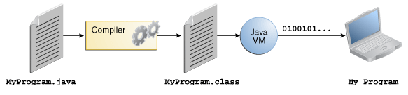

## The Java Platform

A platform is the hardware or software environment in which a program runs. We've already mentioned some of the most popular platforms like Microsoft Windows, Linux, Solaris OS, and Mac OS. Most platforms can be described as a combination of the operating system and underlying hardware. The Java platform differs from most other platforms in that it's a software-only platform that runs on top of other hardware-based platforms.

The Java platform has two components:

* The Java Virtual Machine
* The Java Application Programming Interface (API)

You've already been introduced to the Java Virtual Machine; it's the base for the Java platform and is ported onto various hardware-based platforms.

The API is a large collection of ready-made software components that provide many useful capabilities. It is grouped into libraries of related classes and interfaces; these libraries are known as *packages*. The next section, [What Can Java Technology Do?](http://docs.oracle.com/javase/tutorial/getStarted/intro/cando.html) Highlights some of the functionality provided by the API.

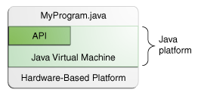

As a platform-independent environment, the Java platform can be a bit slower than native code. However, advances in compiler and virtual machine technologies are bringing performance close to that of native code without threatening portability.

# What Can Java Technology Do?

The general-purpose, high-level Java programming language is a powerful software platform. Every full implementation of the Java platform gives you the following features:

* **Development Tools**: The development tools provide everything you'll need for compiling, running, monitoring, debugging, and documenting your applications. As a new developer, the main tools you'll be using are the javac compiler, the java launcher, and the javadoc documentation tool.
* **Application Programming Interface (API)**: The API provides the core functionality of the Java programming language. It offers a wide array of useful classes ready for use in your own applications. It spans everything from basic objects, to networking and security, to XML generation and database access, and more. The core API is very large; to get an overview of what it contains, consult the [Java Platform Standard Edition 7 Documentation](http://docs.oracle.com/javase/7/docs/index.html).
* **Deployment Technologies**: The JDK software provides standard mechanisms such as the Java Web Start software and Java Plug-In software for deploying your applications to end users.
* **User Interface Toolkits**: The Swing and Java 2D toolkits make it possible to create sophisticated Graphical User Interfaces (GUIs).
* **Integration Libraries**: Integration libraries such as the Java IDL API, JDBC™ API, Java Naming and Directory Interface™ (JNDI) API, Java RMI, and Java Remote Method Invocation over Internet Inter-ORB Protocol Technology (Java RMI-IIOP Technology) enable database access and manipulation of remote objects.

**JAVA Technology help:**

* **Get started quickly**: Although the Java programming language is a powerful object-oriented language, it's easy to learn, especially for programmers already familiar with C or C++.
* **Write less code**: Comparisons of program metrics (class counts, method counts, and so on) suggest that a program written in the Java programming language can be four times smaller than the same program written in C++.
* **Write better code**: The Java programming language encourages good coding practices, and automatic garbage collection helps you avoid memory leaks. Its object orientation, its JavaBeans™ component architecture, and its wide-ranging, easily extendible API let you reuse existing, tested code and introduce fewer bugs.
* **Develop programs more quickly**: The Java programming language is simpler than C++, and as such, your development time could be up to twice as fast when writing in it. Your programs will also require fewer lines of code.
* **Avoid platform dependencies**: You can keep your program portable by avoiding the use of libraries written in other languages.
* **Write once, run anywhere**: Because applications written in the Java programming language are compiled into machine-independent byte codes, they run consistently on any Java platform.

**5.2 BACK END TOOL**

**SQL SERVER**

SQL server 7.0 offers distinct advantages to developers of value-added business solution. This section introduces SQLServer 7.0 to developers who are unfamiliar with client/server database application development or who need a quick refresher on SQL Server 7.0 and MSDN 1.0.

**SCALABLE DATABASE PLATFORM**

SQL Server 7.0 and MSDE 1.0 support all 32 –bit Microsoft Windows platforms (except Win32s®) with a single, compatible code base that dynamically adapts to the hardware capabilities available on the system on which it is installed. This means that developers can write a single set of application source code and run it on a database that scales from a Windows 98 desktop, to a Windows NT Server Enterprise Edition cluster. Database files are also compatible across all SQL Server 7.0 editions. SQL Server 7.0 is available in several different editions that will be briefly introduced here.

**DATABASE SERVER ARCHITECTURE**

There are many robust client/server database engine products available today. SQL Server 7.0 became commercially available in 1999, and although it is compatible with applications written for earlier releases, its core architecture is composed of a completely modern design. As such, SQL Server 7.0 represents a significant evolution in database technology. The basic principles involved in the architecture of the database server and the benefits of this new approach warrant further examination.

**CLIENT/SERVER ARCHITECTURE**

SQL Server 7.0 is an intelligent client/server database engine that differs substantially from traditional personal computer technology that is implemented using a shared file-system approach (such as Borland dBASE, Microsoft Jet, Microsoft Visual FoxPro®, and Pervasive Btrieve). Shared file system database rely on a single client processor per user to manipulate data in shared data files on network files servers. This works well in single user scenarios, but multi-user scenarios introduce the added complexity of concurrency control, which requires these products to use fairly primitive locking mechanisms exposed in the network layer. While thoroughly appropriate for a wide range of personal computer database applications, these systems tend to experience performance and reliability problems under more strenuous multi-user loads. Security facilities for shared file systems database are typically limited to simple read/write network permissions, making it easy for user to access shared data files outside of the context of the application they were designed for by using a different tool. This makes it difficult to have absolute control over how user interact with a shared data file as a whole and how restricted access is implemented for certain types of operations. As an intelligent database server application, SQL Server supports a well-defined language for server programming and communication called Transact-SQL, and well-defined programming interfaces that client application used to conduct conversation with SQL Server. Transact-SQL is a super set of industry standard ANSI structured query language (ANSI-SQL). ANSI-SQL defines four basic commands for manipulating data in a relational database (SELECT, INSERT, UPDATE, DELETE) a variety of commands for defining the structure of databases and few other categories of commands. Transact SQL expands upon the standard ANSI standard by adding functionality to the four basic data manipulation commands, and by adding control -of-flow constructs for programmability. These extensions makes it possible to program SQL Server with custom business logic might be a standardized database operations such as a stored procedure for updating inventory data, or custom data integrity logic such as trigger that checks current stock level when parts are sold to determine if inventory is low. Some application that need to support a variety of database platform leverage only the ANSI –SQL complaints construct of Transact-SQL ,while other application make extensive use of Transact-SQL programmability to enhance the performance and functionality of SQL Server application.

**SQL SERVER DISTRIBUTED MANAGEMENT OBJECTS**

SQL Server Enterprise Manager and other SQL Server administration tools leverage a shared software component called the SQL Server Distributed Management Objects (SQL-DMO)for performing administrative tasks.

**SQL SERVER AGENT**

SQL Server Agent is an integrated job scheduling and execution environment designed specifically for SQL Server. Using SQL Server Agent, database administrators can write and deploy custom batch jobs for performing a wide variety of database administration tasks from simple single server administration tasks to complex

Multi-server operations. Additionally, SQL Server Agent provides the ability to monitor a vast array of database events and performance characteristics, and generate alerts when specific conditions are encountered. SQL Server Agent can be administered graphically from within SQL Server Enterprise Manager, and can also be configured in an unattended fashion using SQL-DMO.

**ACTIVE DATA OBJECTS (ADO)**

An alternative OLEDB programming model called Active Data Objects (ADO) is provided for developers using any ActiveX complaint development environment, such as Microsoft Visual Basic. ADO provides a greatly simplified data-access programming model for developers who want to leverage OLEDB for Universal Data Access in their applications. The latest editions of Microsoft Visual Basic and Microsoft Visual Basic for Applications use ADO as the standard data access mechanisms for developers building custom applications. ADO fully supports the OLEDB for OLAP Multi-dimensional extensions using corollary extensions called ADO/MD.

**OPEN DATABASE CONNECTIVITY (ODBC)**

Prior to the release of SQL Server 7.0, Microsoft ODBC was the preferred data access API for developing custom SQL Server applications. SQL Server 7.0 fully supports ODBC and includes an updated ODBC driver that provides access to all the new features and capabilities available in the database server. Applications written to support earlier releases of the Microsoft ODBC SQL Server driver are fully compatible with SQL Server 7.0, but may not have access to a variety of new features and capabilities provided in the most recent release. Microsoft will continue to support ODBC as a native SQL Server data access interface for the foreseeable future.

**QUERY LANGUAGE SUPPORT (TRANSACT-SQL)**

SQL Server 7.0 supports its own native query language called Transact-SQL. Transact-SQL is compatible with the American National Standard for Database Language SQL (ANSI X3.135-1992),which improves interoperability between SQL Server and other database products that support the same standard (for example , Oracle, Sybase, IBMDB/32).

Transact-SQL offers significant enhancements to the ANSI standard , improving the power and flexibility of custom applications developed for SQL Server 7.0. Transact SQL supports the four basic data manipulation language (DML) commands common to all SQL dialects:

* The SELECT command is used to retrieve information from relational tables. This command is incredibly rich, allowing for both simple queries and complicated multi-table queries that correlate information among multiple tables (called a “join”).
* The INSERT command is used to add new rows to a relational table
* The UPDATE command is used to modify existing data values stored in columns in a relational table.
* The DELETE command is used to delete rows from a relational table.

Transact-SQL also supports a second category of commands known as data definition language (DDL). These commands enable developers to create new database objects such as tables and indexes, apply security permissions to these objects, and generally manage the structure of a database.

**DEVELOPING WEB APPLICATIONS**

Most applications built for the Web or corporate intranets require a database for storage and retrieval of structured information. Microsoft SQL Server 7.0 is an ideal database platform for Web-based applications for a variety of reasons.

* Native support for ADO access. ADO is the preferred data access interface when developing Web-based applications using Internet Information Services (IIS) and Active Server Pages (ASP).
* Web data publishing and retrieval of HTML table data using the SQL Sever Web Assistant.
* Web data distribution using SQL Server 7.0 replication and “anonymous subscribers”.

Support for TCP/IP, encryption and firewalls for applications requiring a direct connection to the database over the Internet.

**6. IMPLEMENTATION**

**6.1 SOURCE CODE**

**Intex.html**

<html>

<head>

<frameset rows=20%,70%>

<frame src="head.html">

<frameset cols=20%,70%>

<frame src="img1.html">

<frame src="main.html">

</head>

</html>

**Head.html**

<html>

<body background="7.jpg">

<h1><B><CENTER>

CAMPUS RECRUITMENT SYSTEM

</B></CENTER>

</H1></body>

</html>

**Img.html**

<html>

<body>

<marquee direction=up behaviour="scroll" onmouseover=stop() onmouseout=start()>

<table><tr><Td>

<imgsrc=Q.png>

<tr><Td><imgsrc=Q.png>

</marquee>

</body>

</html>

**Main.html**

<html>

<body>

<table border=0 align=center cellspacing=10 cellpadding=10>

<tr><td><a href="home.jsp"><input type=button name=b1 value="HOME"></a>

<td><a href="stulog.jsp"><input type=button name=b2 value="STUDENT"></a>

<td><a href="managelog.jsp"><input type=button name=b3 value="MANAGEMENT"></a>

<td><a href="companylog.jsp"><input type=button name=b4 value="COMPANY"></a>

<td><a href="reg.jsp"><input type=button name=b4 value="REGISTER"></a>

</TR></table></body></html>

**Stulog.jsp**

<%@ include file="main.html"%>

<%@page import="java.io.*;"%>

<%@page import="java.sql.*"%>

<html>

<body background="slogin.jpg">

<form action="student.html" method="post">

<table border=10 bgcolor="cyan" cellsapcing=5 cellpadding=5 align=center>

<tr><thcolspan=2>STUDENT FORM</tr>

<tr><th>USERNAME<td><input type="text" name=t1></tr>

<tr><th>PASSWORD<td><input type="password" name=t2></tr>

<tr><thcolspan=2><ahref="stulog.jsp"><input type="submit" name=b1 value="login"></tr>

<%

try{

String un=request.getParameter("t1");

String pw=request.getParameter("t2");

if(request.getParameter("b1")!=null)

{

if(un.equalsIgnoreCase("Admin")&&pw.equalsIgnoreCase("Admin"))

{response.sendRedirect("student.html");}

else{%><script>alert("Login fail");</script>

<%}}}

catch(Exception e)

{out.println(e);}

%></table></form></body></html>

**Student.html**

<html>

<body background="1.png">

<table border=0 align=center cellspacing=10 cellpadding=10>

<tr><td><a href="shome.jsp"><input type=button name=b1 value="HOME"></a>

<td><a href="searchcom.jsp"><input type=button name=b2 value="SEARCH COMPANY"></a>

<td><a href="placement.jsp"><input type=button name=b3 value="PLACEMENT SEARCHING"></a>

<td><a href="application.jsp"><input type=button name=b4 value="APPLICATION SENT"></a>

<td><a href="selectall.jsp"><input type=button name=b4 value="VIEW SELECTED LIST"></a>

<td><a href="main.html"><input type=button name=b4 value="LOGOUT"></a>

</TR></table></body></html>

**Shome.jsp**

<%@include file="student.html" %>

<html><body>

<u><i><b><h1>

<MARQUEE behaviour=scroll direction=left onmouseover=stop() onmouseout=start()>

WELCOME TO STUDENT SECTION

</marquee></U><I></B></H1></body></html>

**Searchcom.jsp**

<%@ include file="student.html"%>

<%@page import="java.io.*;"%>

<%@page import="java.sql.*;"%>

<html><body>

<form action="searchcom.jsp" method="post">

<table border="3" bgcolor="pink" cellspacing=5 cellpadding=5 align=center>

<tr><th>COMPANY NAME

<td><input type="text" name=t1></tr><tr>

<thcolspan=2><input type="submit" name=b1 value=cilck>

</table>

<%

try{

String cn=request.getParameter("d");

String stat="pending";

if(request.getParameter("b1")!=null)

{

Class.forName("com.mysql.jdbc.Driver");

Connection c=DriverManager.getConnection("jdbc:mysql://localhost:3306/campus","root","root");

PreparedStatementps=c.prepareStatement("select*from reg where cn=? and status=?");

ps.setString(1,cn);

ps.setString(2,stat);

ResultSetrs=ps.executeQuery();

%>

<table border="3" bgcolor="pink" cellspacing=5 cellpadding=5 align=center>

<tr><Td>Company ID<td>Company Name<td>Experience

<td>Mail id<td>Phone no<td>Branch count<td>Area<td>Date<td>Status<td>Accept</tr><%

while(rs.next())

{%>

<tr><td><%=rs.getInt(1)%>

<td><%=rs.getString(2)%>

<td><%=rs.getInt(3)%>

<td><%=rs.getString(4)%>

<td><%=rs.getString(5)%>

<td><%=rs.getInt(6)%>

<td><%=rs.getString(7)%>

<td><%=rs.getString(8)%>

<td><%=rs.getString(9)%>

<td><a href="addcom.jsp"><input type=button name=b1 value="CLICK"></a></td></tr>

<%}}}

catch(Exception e)

{out.println(e);}

%></table>

</form></body></html>

**Placement.jsp**

<%@ include file="student.html"%>

<%@page import="java.io.*;"%>

<%@page import="java.sql.*;"%>

<html>

<body>

<form action="placement.jsp" method="post">

<table border="3" bgcolor="pink" cellspacing=5 cellpadding=5 align=center>

<tr><td colspan=2 align=cente>PLACEMENT SEARCHING</td></tr>

<tr><th>DATE<td><input type="date" name=t1></tr>

<tr><th>COMPANY NAME<td><input type="text" name=t2></tr>

<tr><thcolspan=2><input type="submit" name=b1 value=cilck>

</table>

<%

try{

String date=request.getParameter("t1");

String cpna=request.getParameter("t2");

if(request.getParameter("b1")!=null)

{out.println(date);

out.println(cpna);

Class.forName("com.mysql.jdbc.Driver");

Connection c=DriverManager.getConnection("jdbc:mysql://localhost:3306/campus","root","root");

PreparedStatementps=c.prepareStatement("select * from addplacement where cpna=? and date=?");

ps.setString(1,cpna);

ps.setString(2,date);

ResultSetrs=ps.executeQuery();

%>

<table border="3" bgcolor="pink" cellspacing=5 cellpadding=5 align=center>

<tr><td>Company name

<td>placement id

<td>designation

<td>post

<td>Branch

<td>Date

<td>Accept

</tr>

<%

while(rs.next())

{

%>

<tr><td><%=rs.getString(1)%>

<td><%=rs.getInt(2)%>

<td><%=rs.getString(3)%>

<td><%=rs.getString(4)%>

<td><%=rs.getInt(5)%>

<td><%=rs.getString(6)%>

<td><a href="addplace.jsp"><input type=button name=b1 value="CLICK"></a></td></tr>

<%}}}

catch(Exception e)

{out.println(e);}

%>

</table>

</form>

</body>

</html>

**Application.jsp**

<%@ include file="student.html"%>

<%@page import="java.io.*;"%>

<%@page import="java.sql.*;"%>

<html>

<body>

<form action="application.jsp" method="post">

<table border=10 bgcolor="yellow" cellspacing=5 cellpadding=5 align=center>

<tr><thcolspan=2>APPLICATION SEND</tr>

<%

try{

Class.forName("com.mysql.jdbc.Driver");

Connection c=DriverManager.getConnection("jdbc:mysql://localhost:3306/campus","root","root");

PreparedStatement p=c.prepareStatement("select max(si) from application");

ResultSetrs=p.executeQuery();

if(rs.next())

{int a=rs.getInt(1);

int b=a+1;

out.println("<tr><th>STUDENT ID<td><input type=text name=t1 value="+b+" readonly></tr>");

%>

<tr><th>COMPANY NAME<td><input type=text name=t2></tr>

<tr><th>PLACEMENT ID<td><input type=text name=t3></tr>

<tr><th>POST<td><input type=text name=t4></tr>

<tr><th>QUALIFICATION<td><input type=text name=t5></tr>

<tr><th>APPLYING ID<td><input type=text name=t6></tr>

<tr><th>DATE<td><input type=date name=t7></tr>

<tr><th>BRANCH ID<td><input type=text name=t8></tr>

<tr><thcolspan=2><input type="submit" name=b1 value="POST"></tr>

<%

intsi=Integer.parseInt(request.getParameter("t1"));

String comn=request.getParameter("t2");

intplid=Integer.parseInt(request.getParameter("t3"));

String post=request.getParameter("t4");

String quali=request.getParameter("t5");

intapid=Integer.parseInt(request.getParameter("t6"));

String date=request.getParameter("t7");

String brid=request.getParameter("t8");

String status="pending";

if(request.getParameter("b1")!=null)

{

PreparedStatementps=c.prepareStatement("insert into application values(?,?,?,?,?,?,?,?,?)");

ps.setInt(1,si);

ps.setString(2,comn);

ps.setInt(3,plid);

ps.setString(4,post);

ps.setString(5,quali);

ps.setInt(6,apid);

ps.setString(7,date);

ps.setString(8,brid);

ps.setString(9,status);

int x=ps.executeUpdate();

if(x>0)

{out.println("<script>alert('REGISTRATION IS SUCCESFULL');</script>");}

else

{out.println("<script>alert('Insert fail');</script>");

}}}}

catch(Exception e)

{out.println(e);}

%>

</table>

</form>

</body>

</html>

**Selectall.jsp**

<%@ include file="student.html"%>

<%@page import="java.io.*;"%>

<%@page import="java.sql.*;"%>

<html>

<body>

<form action="genrep.jsp" method="post">

<table border=10 bgcolor="yellow" cellspacing=5 cellpadding=5 align=center>

<%

try

{Class.forName("com.mysql.jdbc.Driver");

Connection c=DriverManager.getConnection("jdbc:mysql://localhost:3306/campus","root","root");

PreparedStatementps=c.prepareStatement("select * from generatereport");

%>

<tr><td>STUDENT NAME

<td>POSITION

<td>BRANCH

<td>APPOINTMENT ID

<td>DATE</tr>

<%

ResultSetrs=ps.executeQuery();

while(rs.next())

{%>

<tr><td><%=rs.getString(1)%></td>

<td><%=rs.getInt(2)%></td>

<td><%=rs.getInt(3)%></td>

<td><%=rs.getInt(4)%></td>

<td><%=rs.getString(5)%></td></tr>

<%

}}

catch(Exception e)

{out.println(e);}

%>

</table>

</form>

</body>

</html>

**Managelog.jsp**

<%@ include file="main.html"%>

<%@page import="java.io.*;"%>

<%@page import="java.sql.*"%>

<html>

<body background="mlogin.jpg">

<br><Br>

<form action="management.html" method="post">

<table border=10 bgcolor="cyan" cellsapcing=5 cellpadding=5 align=center>

<tr><thcolspan=2>MANAGEMENT FORM</tr><tr>

<th>USERNAME<td><input type="text" name=t1></tr>

<tr><th>PASSWORD<td><input type="password" name=t2></tr>

<tr><thcolspan=2><ahref="managelog.jsp"><input ype="submit" name=b1 value="login"></tr>

<%

try{

String un=request.getParameter("t1");

String pw=request.getParameter("t2");

if(request.getParameter("b1")!=null)

{if(un.equalsIgnoreCase("Admin")&&pw.equalsIgnoreCase("Admin"))

{response.sendRedirect("managememt.html");

}

else{

%>

<script>

alert("Login fail");

</script>

<%}}}

catch(Exception e)

{out.println(e);}

%>

</table>

</form>

</body>

</html>

**Management.html**

<html>

<body background="7.jpg">

<table border=0 align=center cellspacing=10 cellpadding=10>

<tr><td><a href="mhome.jsp"><input type=button name=b1 value="HOME"></a>

<td><a href="addcom.jsp"><input type=button name=b2 value="ADD COMPANY"></a>

<td><a href="viewapp.jsp"><input type=button name=b3 value="VIEW APPLICATION AND SENT"></a>

<td><a href="checksel.jsp"><input type=button name=b4 value="CHECK SELECTED LIST"></a>

<td><a href="removecom.jsp"><input type=button name=b5 value="REMOVE COMPANY"></a>

<td><a href="main.html"><input type=button name=b6 value="LOGOUT"></a>

</TR></table></body></html>

**Mhome.jsp**

<%@include file="management.html" %>

<html>

<body>

<u><i><b><h1>

<MARQUEE behaviour=scroll direction=left onmouseover=stop() onmouseout=start()>

WELCOME TO MANAGER SECTION

</marquee>

</U><I></B></H1>

</body></html>

**Addcom.jsp**

<%@include file="management.html"%>

<%@page import="java.io.*;"%>

<%@page import="java.sql.*;"%>

<html>

<body>

<form action="addcom.jsp" method="post">

<table border="3" bgcolor="pink" cellspacing=5 cellpadding=5 align=center>

<tr><th>Date<td><input type="date" name=d></tr>

<tr><thcolspan=2><input type="submit" name=b1 value=cilck></table>

<%try{

String da=request.getParameter("d");

String stat="pending";

if(request.getParameter("b1")!=null)

{Class.forName("com.mysql.jdbc.Driver");

Connection c=DriverManager.getConnection("jdbc:mysql://localhost:3306/campus","root","root");

PreparedStatementps=c.prepareStatement("select*from reg where date=? and status=?");

ps.setString(1,da);

ps.setString(2,stat);

ResultSetrs=ps.executeQuery();

%>

<table border="3" bgcolor="pink" cellspacing=5 cellpadding=5 align=center>

<tr><Td>Company ID

<td>Company Name

<td>Experience

<td>Mail id

<td>Phone no

<td>Branch count

<td>Area

<td>Date

<td>Status

<td>Accept</tr>

<%

while(rs.next())

{

%>

<tr><td><%=rs.getInt(1)%>

<td><%=rs.getString(2)%>

<td><%=rs.getInt(3)%>

<td><%=rs.getString(4)%>

<td><%=rs.getString(5)%>

<td><%=rs.getInt(6)%>

<td><%=rs.getString(7)%>

<td><%=rs.getString(8)%>

<td><%=rs.getString(9)%>

<td><a href="acom.jsp"><input type=button name=b1 value="CLICK"></a></td></tr>

<%

}}}

catch(Exception e)

{out.println(e);}

%>

</table>

</form>

</body>

</html>

**Viewapp.jsp**

<%@include file="management.html"%>

<%@page import="java.io.*;"%>

<%@page import="java.sql.*;"%>

<html>

<body>

<form action="viewapp.jsp" method="post">

<table border="3" bgcolor="pink" cellspacing=5 cellpadding=5 align=center>

<tr><td colspan=2 align=cente>VIEW APPLICATION SEND</td></tr>

<tr><th>DATE<td><input type="date" name=t1></tr>

<tr><thcolspan=2><input type="submit" name=b1 value=cilck>

</table></tr>

<%

try

{

String date=request.getParameter("t1");

if(request.getParameter("b1")!=null)

{

Class.forName("com.mysql.jdbc.Driver");

Connection c=DriverManager.getConnection("jdbc:mysql://localhost:3306/campus","root","root");

PreparedStatementps=c.prepareStatement("select * from application where date=?");

ps.setString(1,date);

ResultSetrs=ps.executeQuery();

%>

<table border="3" bgcolor="pink" cellspacing=5 cellpadding=5 align=center>

<tr><td>student id

<td>company name

<td>placement id

<td>post

<td>qualification

<td>applying id

<td>date

<td>branch id

<td>status</tr>

<%while(rs.next())

{

%>

<tr><td><%=rs.getInt(1)%>

<td><%=rs.getString(2)%>

<td><%=rs.getInt(3)%>

<td><%=rs.getString(4)%>

<td><%=rs.getString(5)%>

<td><%=rs.getInt(6)%>

<td><%=rs.getString(7)%>

<td><%=rs.getInt(8)%>

<td><%=rs.getString(9)%>

<td><a href="application.jsp"><input type=button name=b1 value="CLICK"></a></td></tr>

<%

}}}

catch(Exception e)

{out.println(e);}

%>

</table>

</form>

</body>

</html>

**Checksel.jsp**

<%@include file="management.html"%>

<%@page import="java.io.*;"%>

<%@page import="java.sql.*;"%>

<html>

<body>

<form action="reg.jsp" method="post">

<table border=10 bgcolor="yellow" cellspacing=5 cellpadding=5 align=center>

<%

try

{Class.forName("com.mysql.jdbc.Driver");

Connection c=DriverManager.getConnection("jdbc:mysql://localhost:3306/campus","root","root");

PreparedStatementps=c.prepareStatement("select * from reg");

%>

<tr><td>COMPANY ID

<td>COMPANY NAME

<td>EXPERIENCE

<td>MAIL ID

<td>PHONE NO

<td>BRANCH COUNT

<td>AREA

<td>DATE

<td>STATUS</tr>

<%

ResultSetrs=ps.executeQuery();

while(rs.next())

{

%>

<tr><td><%=rs.getInt(1)%></td>

<td><%=rs.getString(2)%></td>

<td><%=rs.getInt(3)%></td>

<td><%=rs.getString(4)%></td>

<td><%=rs.getString(5)%></td>

<td><%=rs.getInt(6)%></td>

<td><%=rs.getString(7)%></td>

<td><%=rs.getString(8)%></td>

<td><%=rs.getString(9)%></td>

<%

}}

catch(Exception e)

{out.println(e);}

%>

</table>

</form>

</body>

</html>

**Removecom.jsp**

<%@include file="management.html"%>

<%@page import="java.io.*;"%>

<%@page import="java.sql.*;"%>

<html>

<body>

<form action="removecom.jsp" method="post">

<table border="3" bgcolor="pink" cellspacing=5 cellpadding=5 align=center>

<tr><td colspan=2 align=cente>REMOVE COMPANY</td></tr>

<tr><th>COMPANY NAME<td><input type="text" name=t2></tr>

<tr><thcolspan=2><input type="submit" name=b1 value=REMOVE>

<%

try{

String cn=request.getParameter("t2");

if(request.getParameter("b1")!=null)

{Class.forName("com.mysql.jdbc.Driver");

Connection c=DriverManager.getConnection("jdbc:mysql://localhost:3306/campus","root","root");

PreparedStatementps=c.prepareStatement("delete from addplacement where cpna=?");

ps.setString(1,cn);

int x=ps.executeUpdate();

if(x>0)

{out.println("<script>alert('Removed successfull');</script>");}

else

{out.println("<script>alert('Removed fail);</script>");}

}}

catch(Exception e)

{out.println(e);}

%>

</table>

</form>

</body>

</html>

**Companylog.jsp**

<%@ include file="main.html"%>

<%@page import="java.io.*;"%>

<%@page import="java.sql.*"%>

<html>

<body background="clogin.jpg">

<form action="companylog.jsp" method="post">

<br><Br>

<table border=10 bgcolor="cyan" cellsapcing=5 cellpadding=5 align=center>

<tr><thcolspan=2>COMPANY FORM</tr>

<tr><th>USERNAME<td><input type="text" name=t1></tr>

<tr><th>PASSWORD<td><input type="password" name=t2></tr>

<tr><thcolspan=2><input type="submit" name=b1 value="login"></tr>

<%

try{

String ci=request.getParameter("t1");

String mi=request.getParameter("t2");

String status="Accept";

if(request.getParameter("b1")!=null)

{Class.forName("com.mysql.jdbc.Driver");

Connection c=DriverManager.getConnection("jdbc:mysql://localhost:3306/campus","root","root");

PreparedStatementps=c.prepareStatement("select ci,mi,status from reg where ci=? and mi=? and status=?");

ps.setString(1,ci);

ps.setString(2,mi);

ps.setString(3,status);

ResultSetrs=ps.executeQuery();

if(rs.next())

{out.println("<script>alert('company id success');</script>");}

else

{out.println("<script>alert('company id fail');</script>");}

}}

catch(Exception e)

{out.println(e);}

%>

</table>

</form>

</body>

</html>

**Company.html**

<html>

<body background="3.avif">

<table border=0 align=center cellspacing=10 cellpadding=10>

<tr><td><a href="chome.jsp"><input type=button name=b1 value="HOME"></a>

<td><a href="putplace.jsp"><input type=button name=b2 value="PUT PLACEMENT TRAINING"></a>

<td><a href="checkapp.jsp"><input type=button name=b3 value="CHECK APPLICATION"></a>

<td><a href="genrep.jsp"><input type=button name=b4 value="GENERATE REPORT"></a>

<td><a href="viewsd.jsp"><input type=button name=b4 value="VIEW STUDENT DETAILS"></a>

<td><a href="main.html"><input type=button name=b4 value="LOGOUT"></a>

</TR></table></body></html>

**Chome.jsp**

<%@include file="company.html" %>

<html>

<body>

<u><i><b><h1>

<MARQUEE behaviour=scroll direction=left onmouseover=stop() onmouseout=start()>

WELCOME TO COMPANY SECTION

</marquee>

</U><I></B></H1>

</body></html>

**Addplace.jsp**

<%@include file="company.html"%>

<%@page import="java.io.*;"%>

<%@page import="java.sql.*;"%>

<html>

<body>

<form action="addplace.jsp" method="post">

<table border=10 bgcolor="yellow" cellspacing=5 cellpadding=5 align=center>

<tr><thcolspan=2>ADD PLACEMENT</tr>

<tr><th>COMPANY NAME<td><input type=text name=t1></tr>

<tr><th>PLACEMENT ID<td><input type=text name=t2></tr>

<tr><th>DESIGNATION<td><input type=text name="t3"></tr>

<tr><th>POST<td><input type=text name=t4></tr>

<th>BRANCH<td><input type=text name=t5><tr>

<th>DATE<td><input type=date name=t6></tr>

<tr><thcolspan=2><input type="submit" name=b1 value="ADD"></tr>

<%

try

{String cpna=request.getParameter("t1");

int plaid=Integer.parseInt(request.getParameter("t2"));

String des=request.getParameter("t3");

String post=request.getParameter("t4");

int branch=Integer.parseInt(request.getParameter("t5"));

String date=request.getParameter("t6");

if(request.getParameter("b1")!=null)

{

Class.forName("com.mysql.jdbc.Driver");

Connection c=DriverManager.getConnection("jdbc:mysql://localhost:3306/campus","root","root");

PreparedStatementps=c.prepareStatement("insert into addplacement values(?,?,?,?,?,?)");

ps.setString(1,cpna);

ps.setInt(2,plaid);

ps.setString(3,des);

ps.setString(4,post);

ps.setInt(5,branch);

ps.setString(6,date);

int x=ps.executeUpdate();

if(x>0)

{out.println("<script>alert('ADD PLACEMENT IS SUCCESSFULL');</script>");}

else

{out.println("<script>alert('Insert fail');</script>");}

}}

catch(Exception e)

{out.println(e);}

%>

</table>

</form>

</body>

</html>

**Checkapp.jsp**

<%@ include file="company.html"%>

<%@page import="java.io.*;"%>

<%@page import="java.sql.*;"%>

<html>

<body>

<form action="checkapp.jsp" method="post">

<table border="3" bgcolor="pink" cellspacing=5 cellpadding=5 align=center>

<tr><td colspan=2 align=cente>CHECK APPLICATION</td></tr>

<tr>

<th>DATE

<td><input type="date" name=t1>

</tr>

<tr>

<th>COMPANY NAME

<td><input type="text" name=t2>

</tr>

<tr>

<thcolspan=2><input type="submit" name=b1 value=cilck>

</table>

<%

try{

String date=request.getParameter("t1");

String comn=request.getParameter("t2");

if(request.getParameter("b1")!=null)

{Class.forName("com.mysql.jdbc.Driver");

Connection c=DriverManager.getConnection("jdbc:mysql://localhost:3306/campus","root","root");

PreparedStatementps=c.prepareStatement("select * from application where comn=? and date=?");

ps.setString(1,comn);

ps.setString(2,date);

ResultSetrs=ps.executeQuery();

%>

<table border="3" bgcolor="pink" cellspacing=5 cellpadding=5 align=center>

<tr><td>student id

<td>company name

<td>placement id

<td>post

<td>qualification

<td>applying id

<td>date

<td>branch id

</tr>

<%

while(rs.next())

{

%>

<tr><td><%=rs.getInt(1)%>

<td><%=rs.getString(2)%>

<td><%=rs.getInt(3)%>

<td><%=rs.getString(4)%>

<td><%=rs.getString(5)%>

<td><%=rs.getInt(6)%>

<td><%=rs.getString(7)%>

<td><%=rs.getInt(8)%>

<td><a href="application.jsp"><input type=button name=b1 value="CLICK"></a></td></tr>

<%

}}}

catch(Exception e)

{out.println(e);}

%>

</table>

</form>

</body>

</html>

**Genrep.jsp**

<%@include file="company.html"%>

<%@page import="java.io.*;"%>

<%@page import="java.sql.*;"%>

<html>

<body>

<form action="genrep.jsp" method="post">

<table border=10 bgcolor="yellow" cellspacing=5 cellpadding=5 align=center>

<tr><thcolspan=2>GENERATE REPORT</tr>

<th>STUDENT NAME<td><input type=text name=t1></tr>

<tr><th>POSITION<td><input type=text name="t3"></tr>

<th>BRANCH<td><input type=text name=t2></tr>

<tr><th>APPOINTMENT ID<td><input type=text name=t4></tr>

<tr><th>DATE<td><input type=date name=t5></tr>

<tr><thcolspan=2><input type="submit" name=b1 value="GENERATE"></tr>

<%

try

{

String stuna=request.getParameter("t1");

int position=Integer.parseInt(request.getParameter("t2"));

int branch=Integer.parseInt(request.getParameter("t3"));

intappid=Integer.parseInt(request.getParameter("t4"));

String date=request.getParameter("t5");

if(request.getParameter("b1")!=null)

{

Class.forName("com.mysql.jdbc.Driver");

Connection c=DriverManager.getConnection("jdbc:mysql://localhost:3306/campus","root","root");

PreparedStatementps=c.prepareStatement("insert into generatereport values(?,?,?,?,?)");

ps.setString(1,stuna);

ps.setInt(2,position);

ps.setInt(3,branch);

ps.setInt(4,appid);

ps.setString(5,date);

int x=ps.executeUpdate();

if(x>0)

{out.println("<script>alert('GENERATE REPORT IS SUCCESSFULL');</script>");}

else

{out.println("<script>alert('Insert fail');</script>");}

}}

catch(Exception e)

{out.println(e);}

%>

</table>

</form>

</body>

</html>

**Viewsd.jsp**

<%@include file="company.html"%>

<%@page import="java.io.*;"%>

<%@page import="java.sql.*;"%>

<html>

<body>

<form action="viewsd.jsp" method="post">

<table border="3" bgcolor="pink" cellspacing=5 cellpadding=5 align=center>

<%

try

{

Class.forName("com.mysql.jdbc.Driver");

Connection c=DriverManager.getConnection("jdbc:mysql://localhost:3306/campus","root","root");

PreparedStatementps=c.prepareStatement("select * from reg");

%>

<tr><td>company id

<td>company name

<td>experience

<td>mail id

<td>phone no

<td>branch count

<td>area

<td>date

<td>status

</tr>

<%

ResultSetrs=ps.executeQuery();

while(rs.next())

{

%>

<tr><td><%=rs.getInt(1)%>

<td><%=rs.getString(2)%>

<td><%=rs.getInt(3)%>

<td><%=rs.getString(4)%>

<td><%=rs.getString(5)%>

<td><%=rs.getInt(6)%>

<td><%=rs.getString(7)%>

<td><%=rs.getString(8)%>

<td><%=rs.getString(9)%>

<%

}}

catch(Exception e)

{out.println(e);}

%>

</table>

</form>

</body>

</html>

**Reg.jsp**

<%@ include file="main.html"%>

<%@page import="java.io.*;"%>

<%@page import="java.sql.*;"%>

<html>

<body background="reg.jpg">

<form action="reg.jsp" method="post">

<table border=10 bgcolor="yellow" cellspacing=5 cellpadding=5 align=center>

<tr><thcolspan=2>REGISTER</tr>

<%

try

{

Class.forName("com.mysql.jdbc.Driver");

Connection c=DriverManager.getConnection("jdbc:mysql://localhost:3306/campus","root","root");

PreparedStatement p=c.prepareStatement("select max(ci) from reg");

ResultSetrs=p.executeQuery();

if(rs.next())

{

int a=rs.getInt(1);

int b=a+1;

out.println("<tr><th>COMPANY ID<td><input type=text name=t1 value="+b+" readonly></tr>");

%>

<tr><th>COMPANY NAME<td><input type=text name=t2></tr>

<tr><th>EXPERIENCE<td><input type=number name=t3></tr>

<tr><th>MAIL ID<td><input type=email name=t4 placeholder=info@gmail.com></tr>

<tr><th>PHONE NO<td><input type=text name=t5></tr><tr><th>BRANCH COUNT<td><input type=text name=t6>

th>AREA<td><textarea name=t7 resize></textarea></tr>

<tr><th>DATE<td><input type=date name=t8></tr>

<tr><thcolspan=2><input type="submit" name=b1 value="REGISTER"></tr>

<%

int ci=Integer.parseInt(request.getParameter("t1"));

String cn=request.getParameter("t2");

int ex=Integer.parseInt(request.getParameter("t3"));

String mi=request.getParameter("t4");

String pn=request.getParameter("t5");

intbc=Integer.parseInt(request.getParameter("t6"));

String area=request.getParameter("t7");

String date=request.getParameter("t8");

String status="pending";

if(request.getParameter("b1")!=null)

{

PreparedStatementps=c.prepareStatement("insert into reg values(?,?,?,?,?,?,?,?,?)");

ps.setInt(1,ci);

ps.setString(2,cn);

ps.setInt(3,ex);

ps.setString(4,mi);

ps.setString(5,pn);

ps.setInt(6,bc);

ps.setString(7,area);

ps.setString(8,date);

ps.setString(9,status);

int x=ps.executeUpdate();

if(x>0)

{out.println("<script>alert('REGISTRATION IS SUCCESFULL');</script>");}

else

{out.println("<script>alert('Insert fail');</script>");}

}}}

catch(Exception e)

{out.println(e);}

%>

</table>

</form>

</body>

</html>

**6.2 TESTING**

Testing is a process of running software in an intention to find errors the software, which has been developed, has to be tested to prove its validity. Testing is considered to be the least creative phase of the whole cycle of system design. In the real sense it is the phase, which helps to bring out the creativity of the phases.

Testing program is the first step in the debugging process. Some people idea of the testing a program consists of running the program a few times to see what happens, each time using slightly different input. This process can succeed when we have a short program, but it is not effective for a long program. In any case, even for the simplest program the choice of test data is all-important.

A good testing suite is vital because the user must test all possible Execution paths inside the code in order to have any hope it will be bug free. Testing program is an art, not a science. Testing of the system is done to ensure the integrity of the system. Testing is vita for the success of the project, which is the last stage of development. The aim of testing is to prove that the development system addresses the predefined processing requirements and will perform reliably and efficiently during time.

Testing is the process of creating a program with the explicit information of finding error that makes a program fail. Successful test finds the error yet undiscovered. As an additional benefit, testing demonstrates that a software function appear to be working according to the specifications.

## PURPOSES OF TESTING

* To affirm the quality of the project.
* To find and eliminate any errors from previous stages.
* To validate the software and to eliminate the operation.
* Reliability of the system.

**TYPES OF TESTING**

The software, which has been developed, has to be tested to prove its validity. Testing is considered to be the least creative phase of the whole cycle of system design. In the real sense it is the phase, which helps to bring out the creativity of the phases.

The “Time Assessment for molding of casting” was tested along the following guidelines to prove its validity. It was tested using two techniques of software testing.

## UNIT TESTING

In the lines of this strategy all the individual functions and modules were put to the test independently. By following this strategy all the error in coding were identified and corrected. This method was applied in combination with the white and Black box testing techniques to find the errors in each module.

#### SYSTEM TESTING

The idea of applying this strategy was to put the system to a series of different test whose primary purpose is to fully exercise the computer-based system. Although each test has a different purpose, all work to verify that all system elements have been properly integrated and perform allocated functions, security testing was conducted.

#### VALIDATION TESTING

The main aim of this testing is to verify that the software system does what it was designed for Alpha testing and Beta testing were conducted to ensure the validity of the system. A customer conducted the Alpha test at the developer’s site. The end user of the software conducted the Beta test at one or more of the customer site.

**7. OUTPUT**

**7.1 FORMS**

**INDEX**

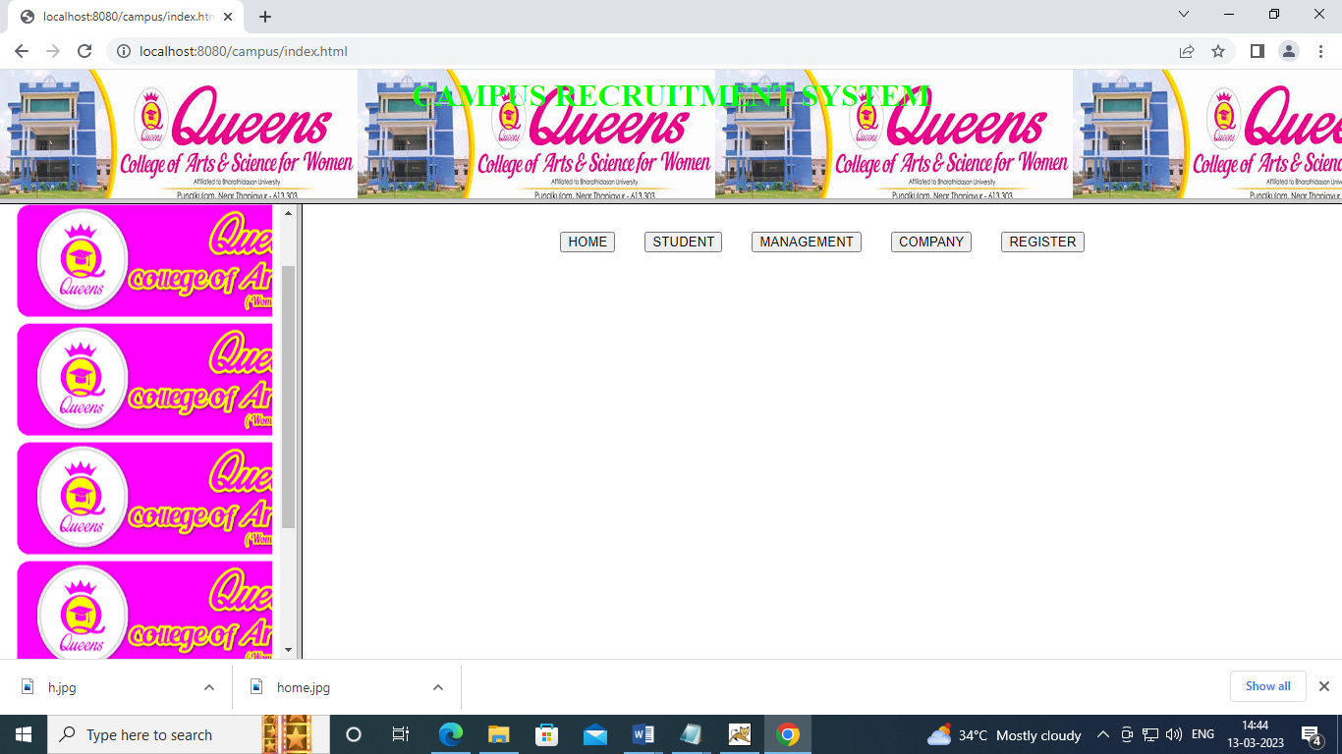

**HOME**

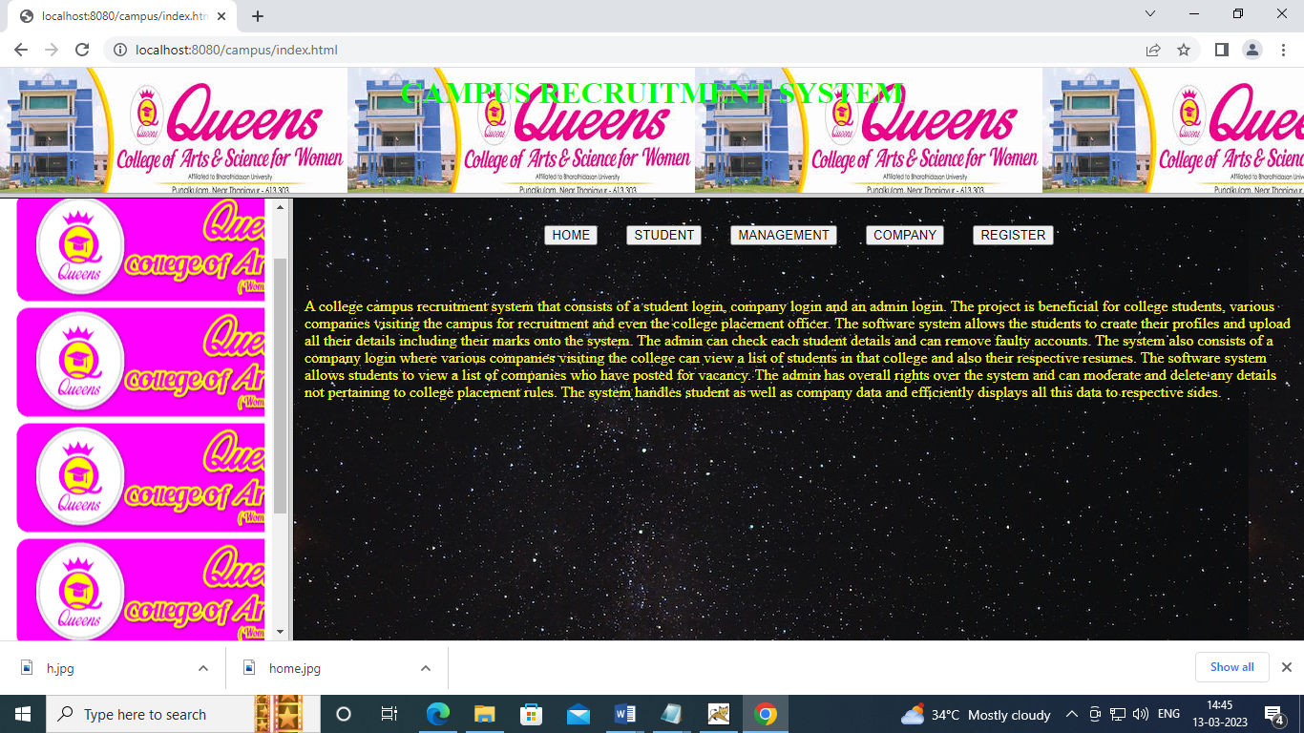

**STUDENTLOG**

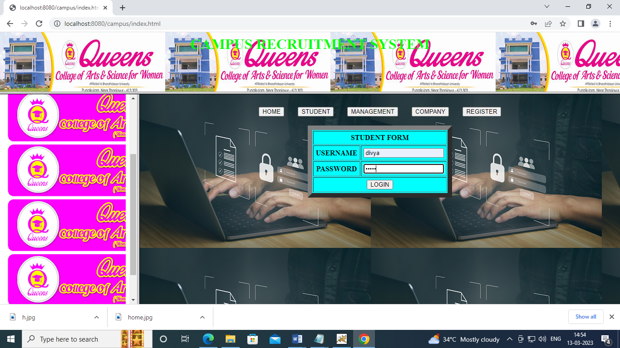

**STUDENT**

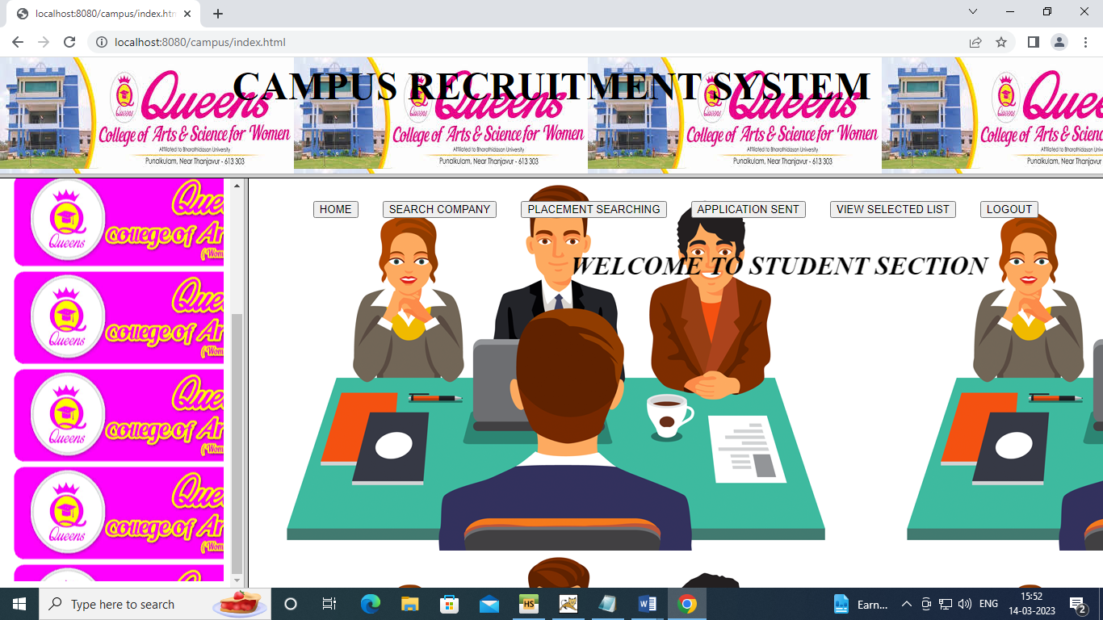

**MANAGELOG**

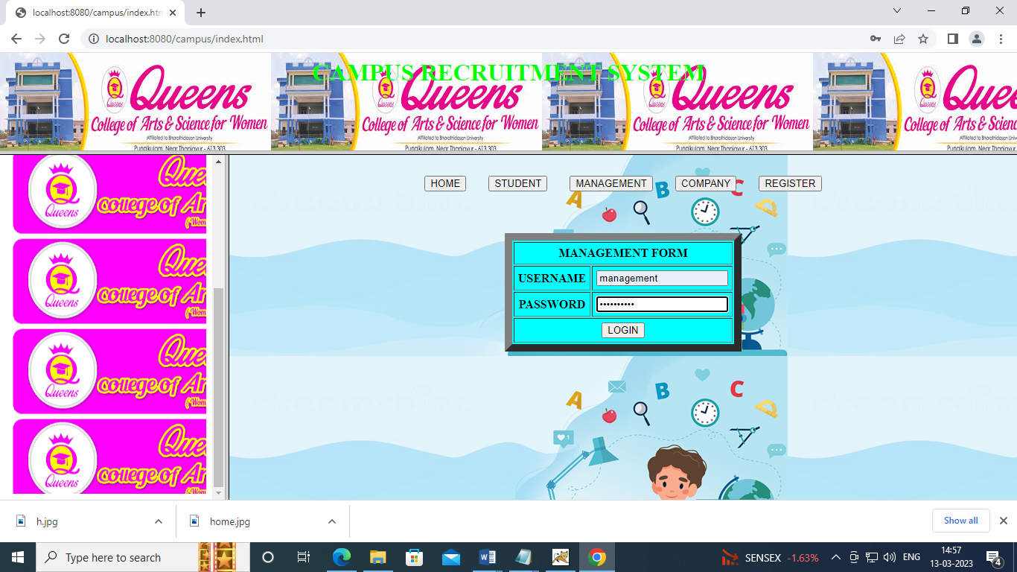

**MANAGEMENT**

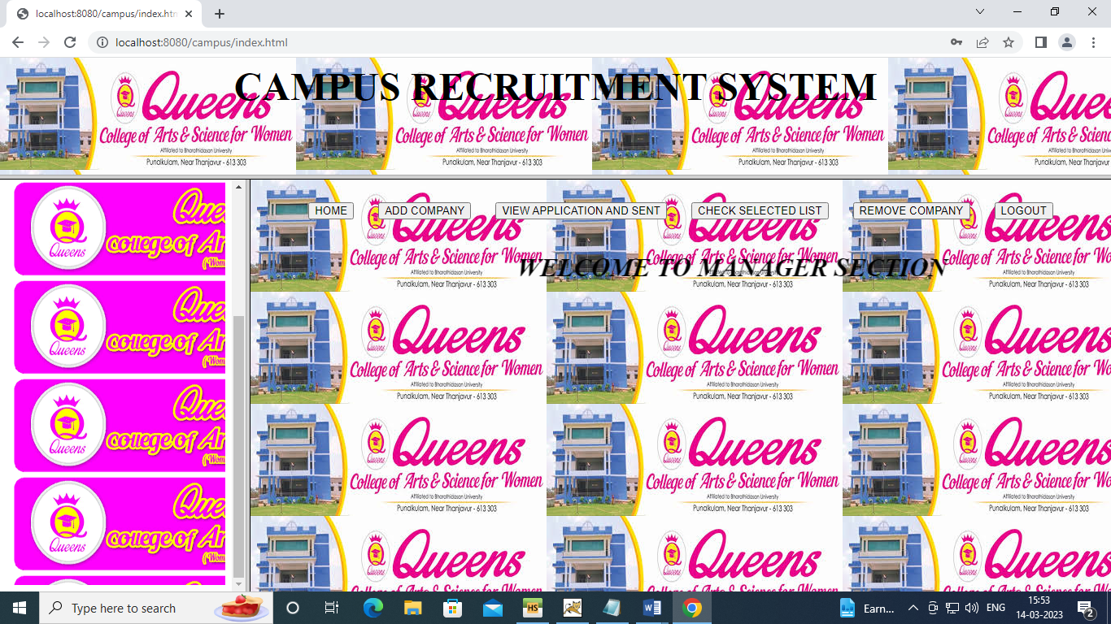

**COMLOG**

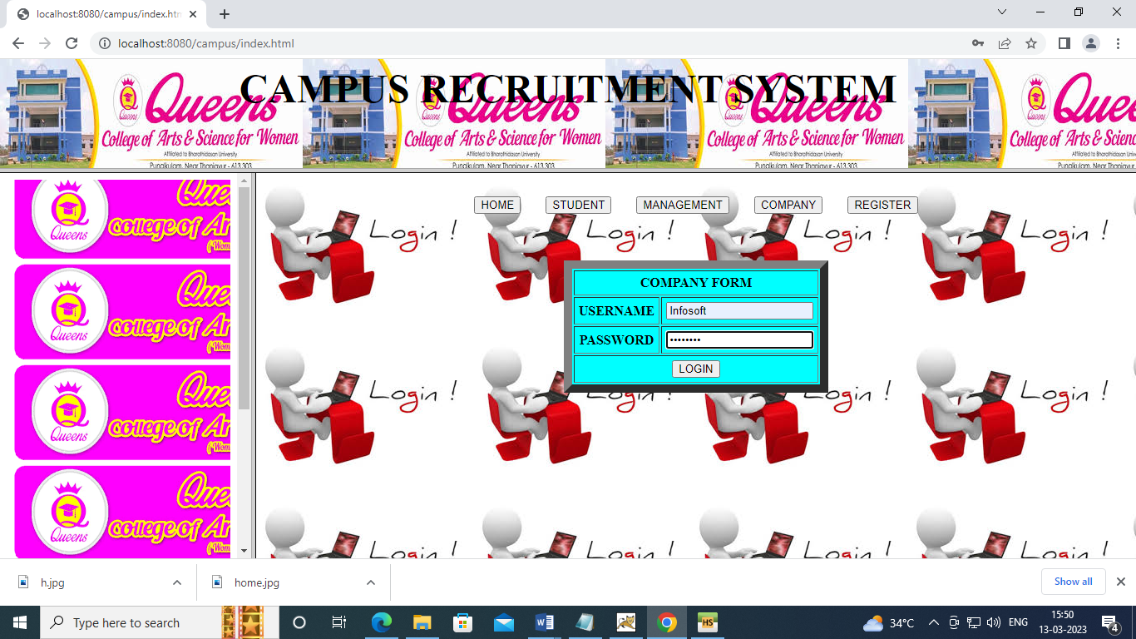

**COMPANY**

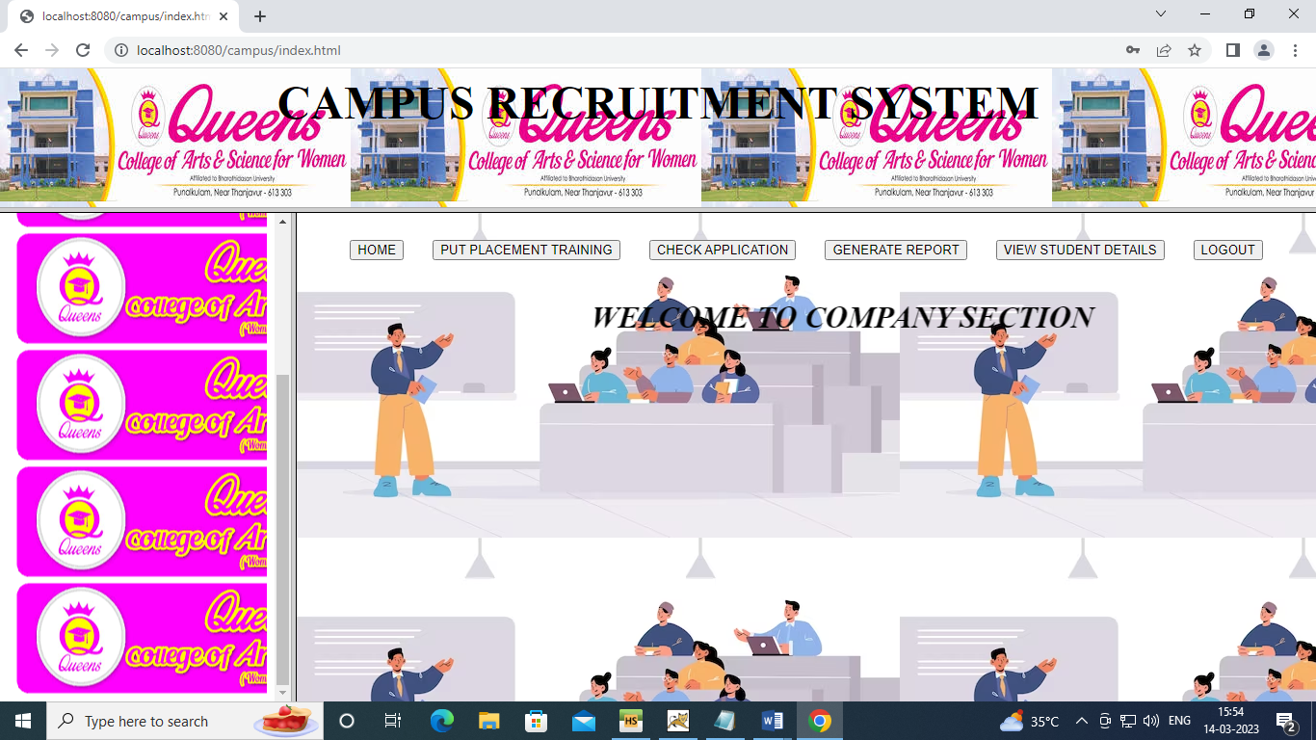

**EARCHCOM**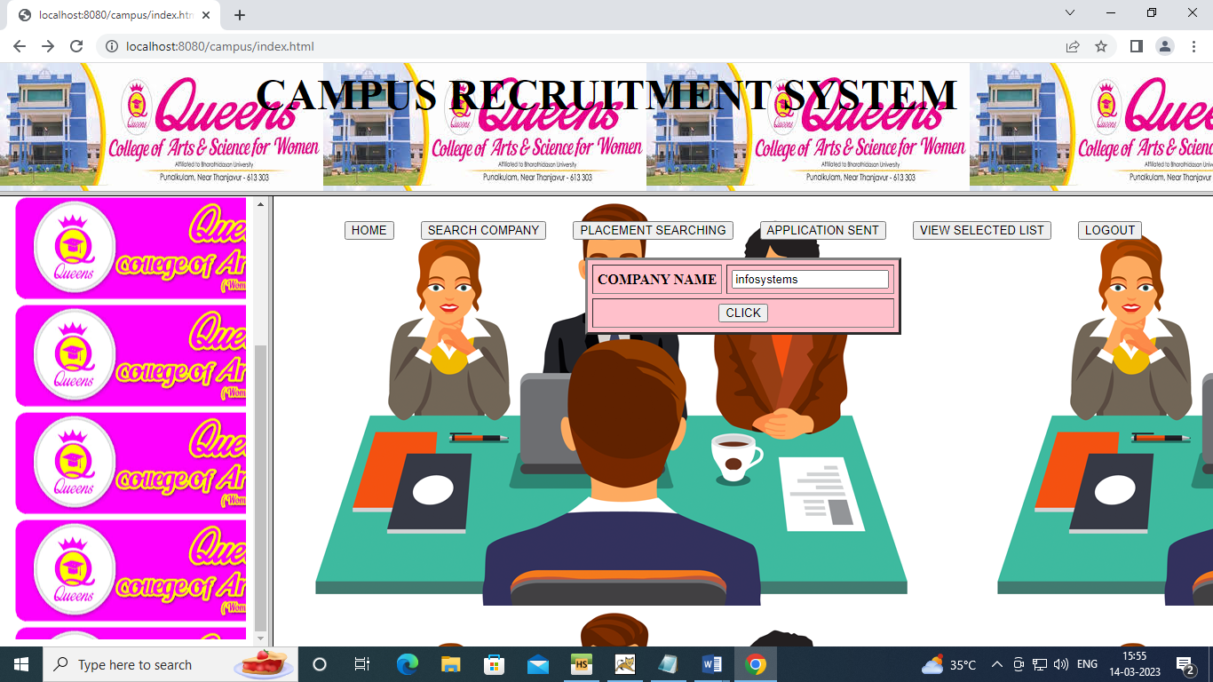

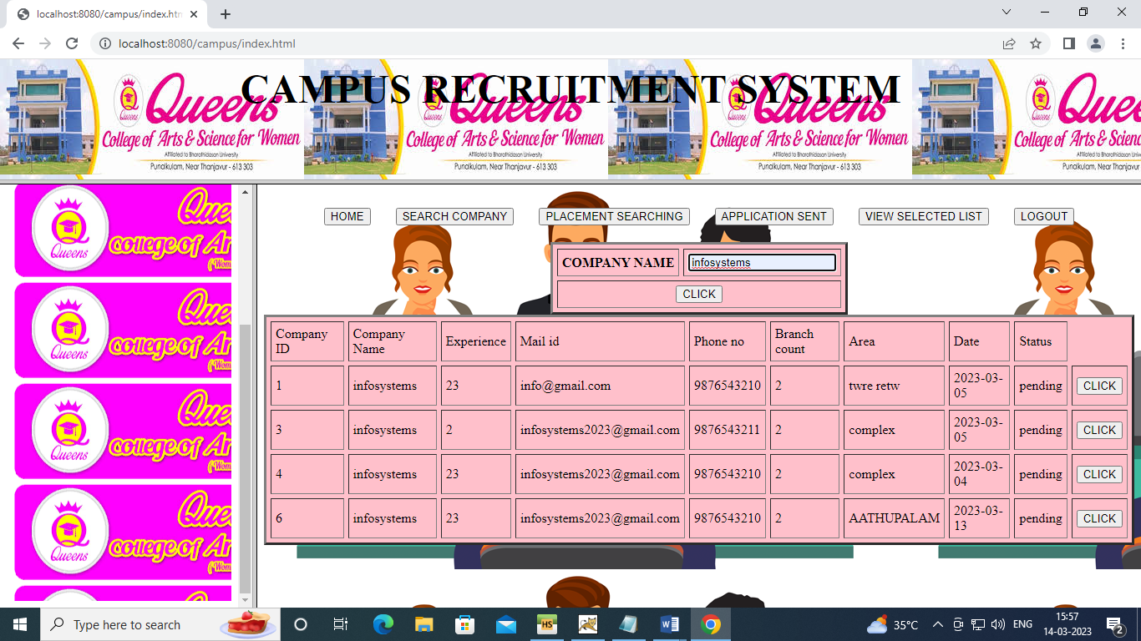

**PLACEMENT**

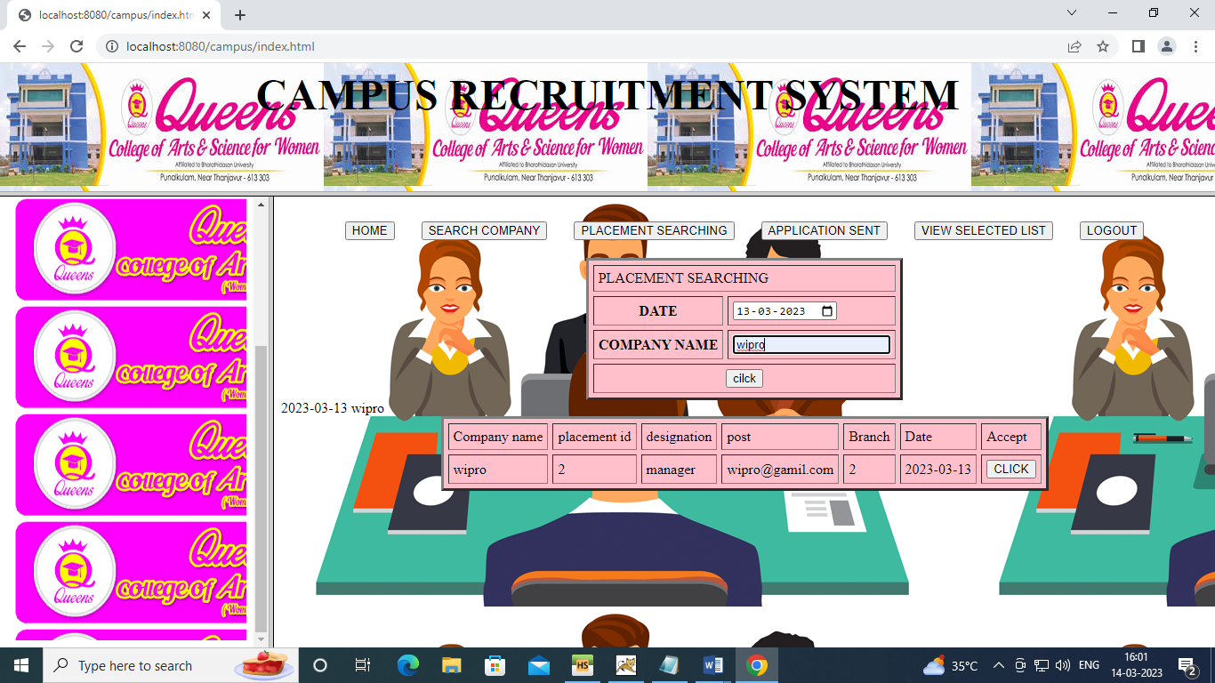

**APPLICATION**

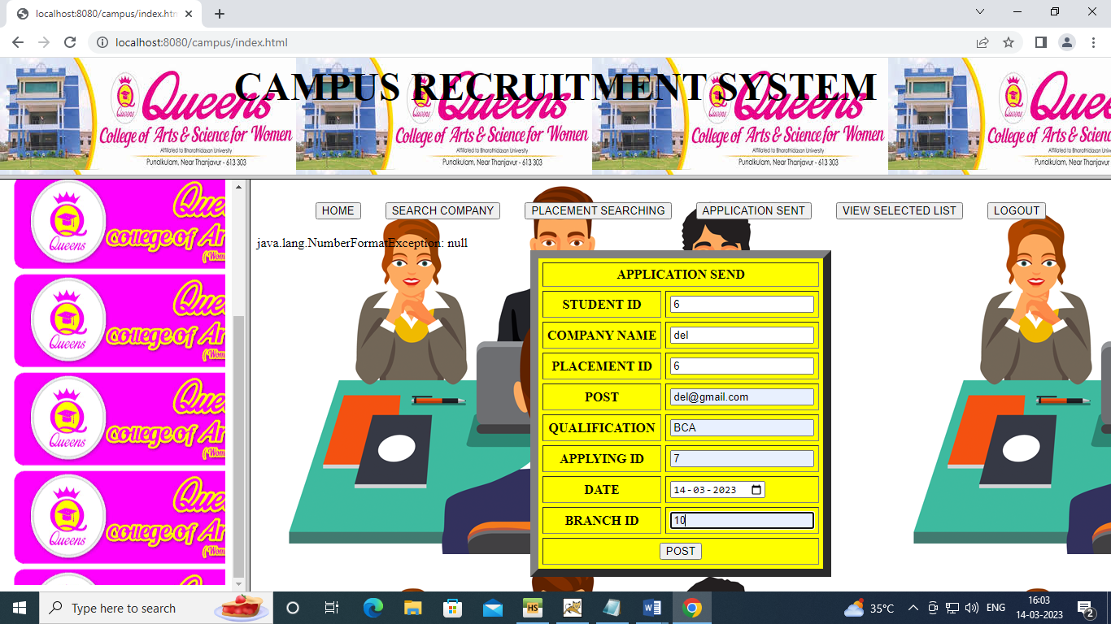

**SELECTALL**

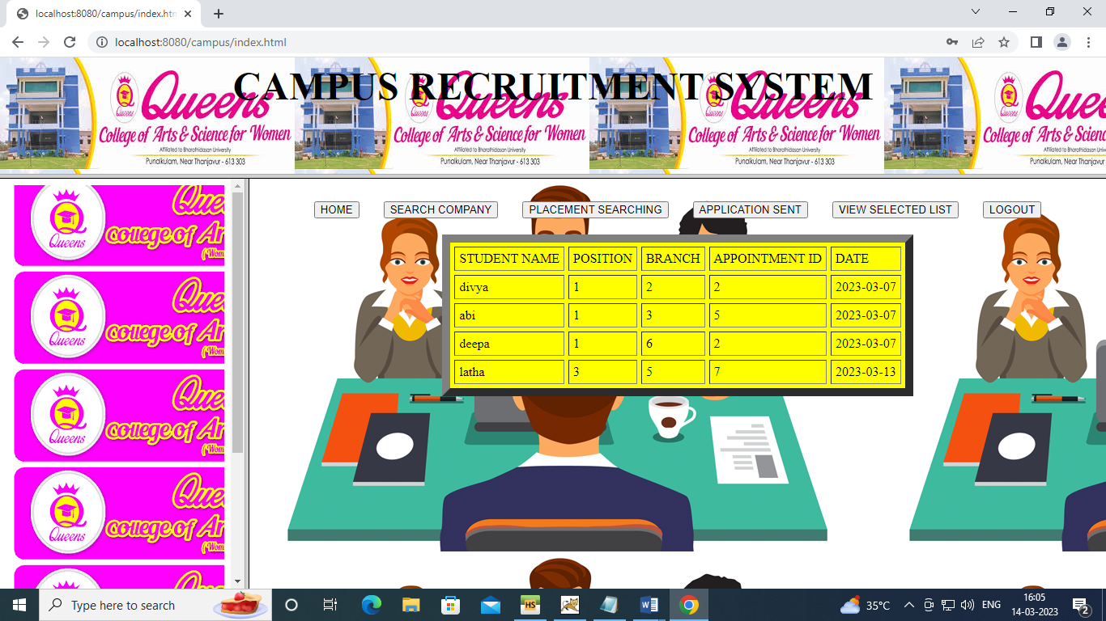

**LOGOUT**

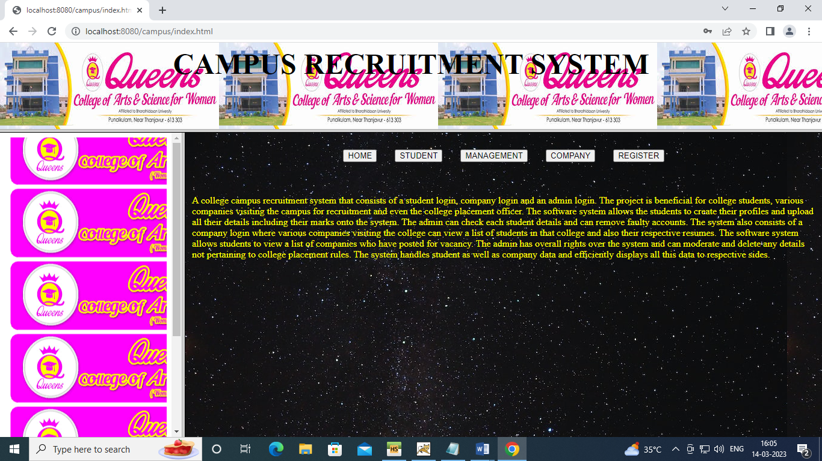

**ADDCOM**

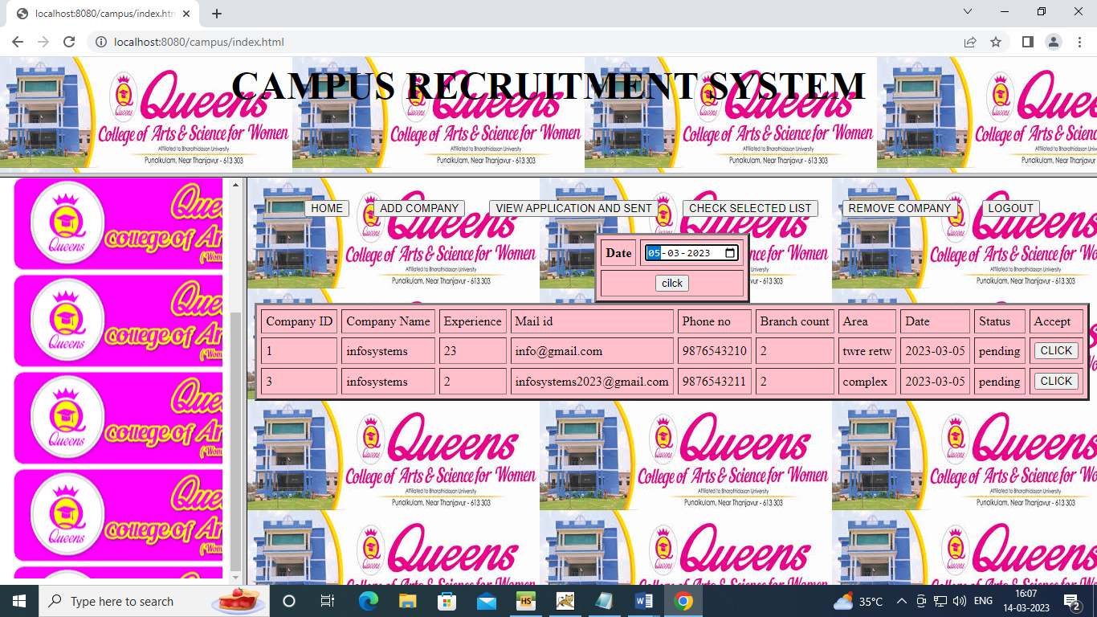

**VIEWAPP**

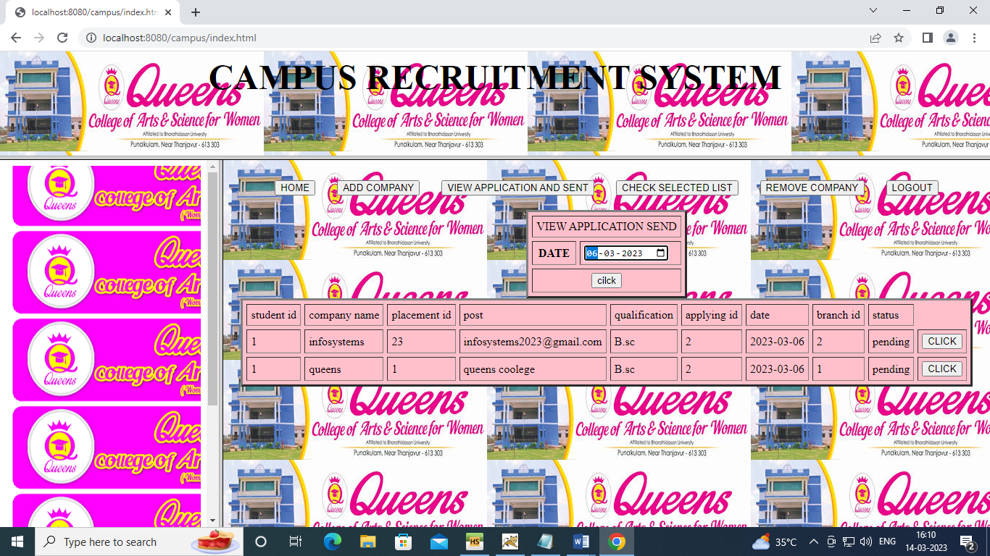

**CHECKSEL**

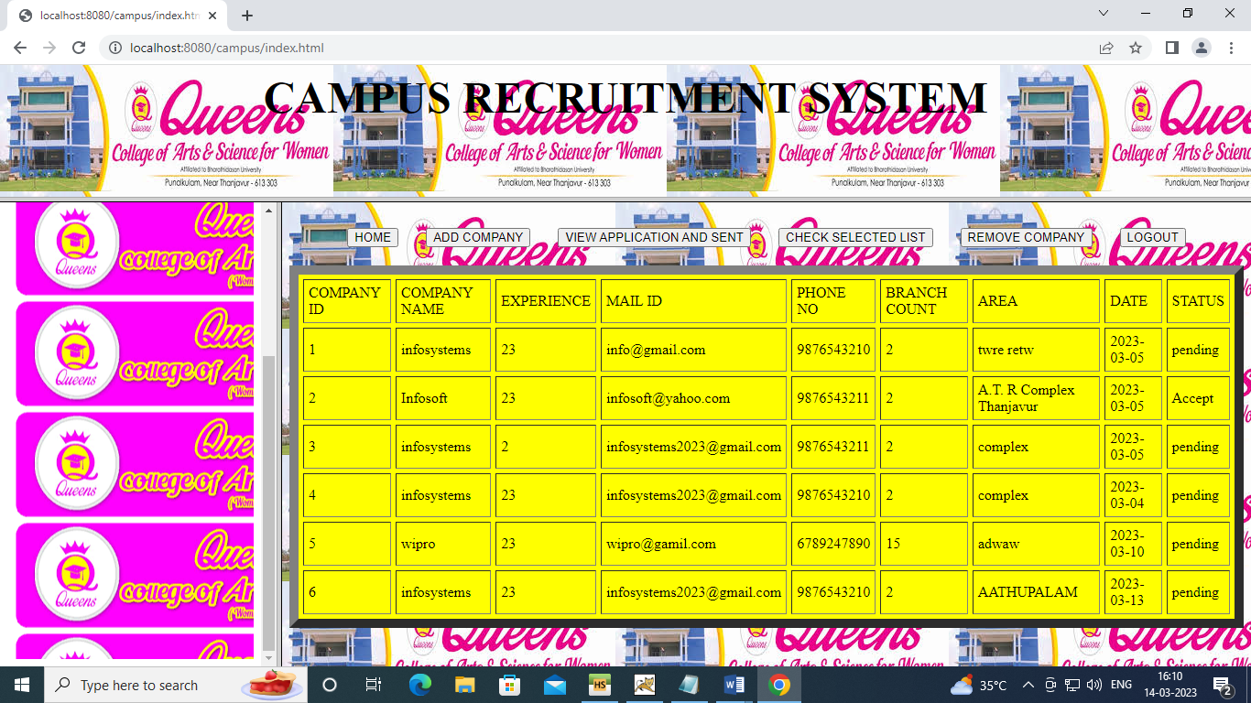

**REMOVECOM**

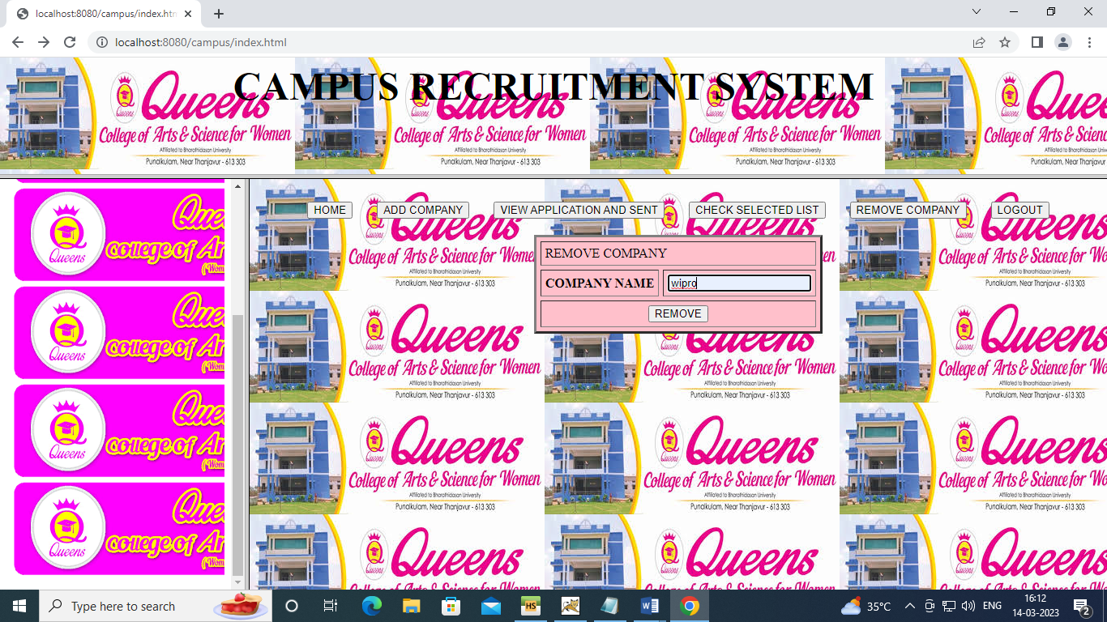

**PUTPLACE**

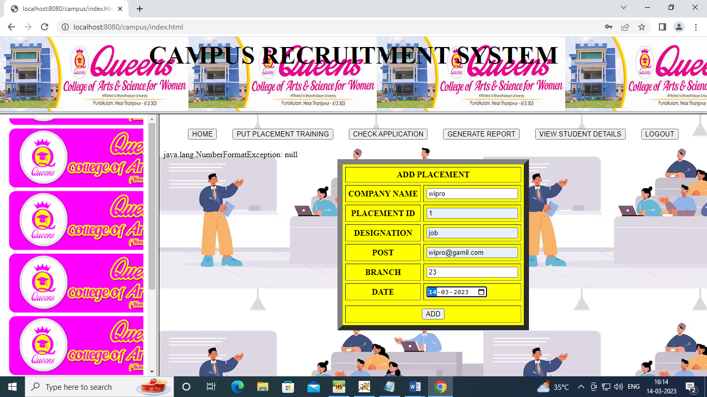

**CHECKAPP**

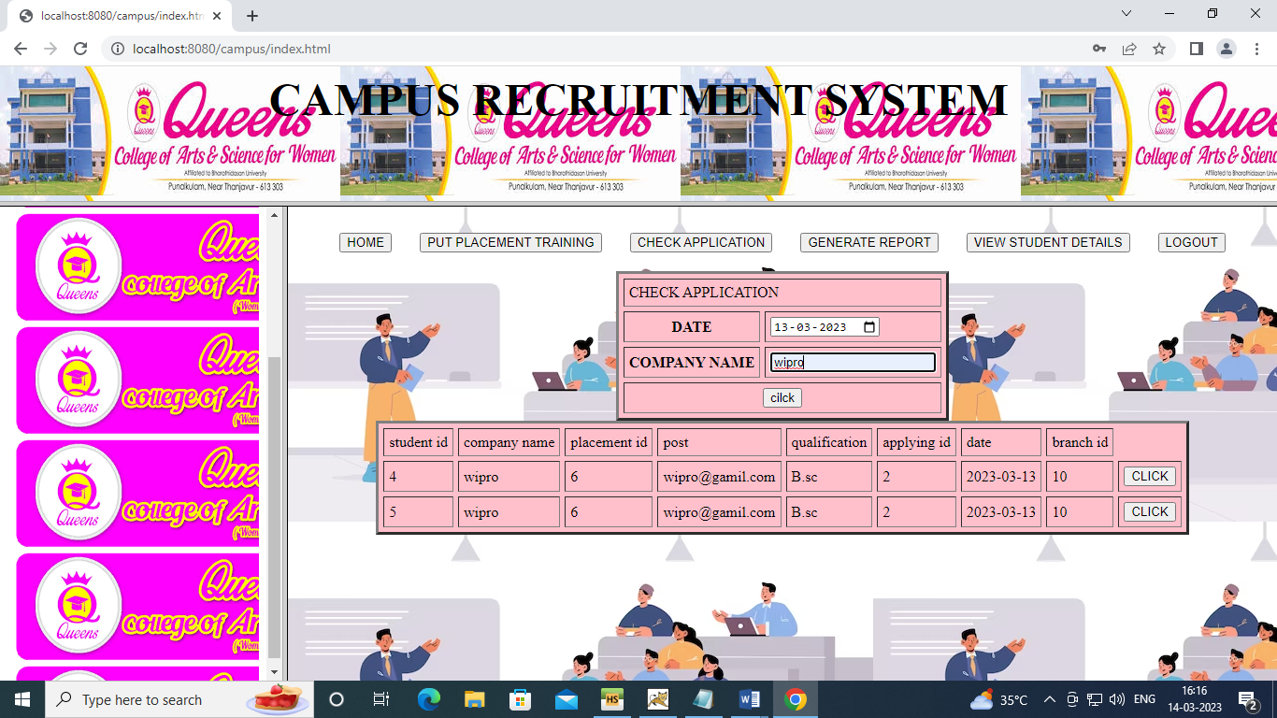

**GENREP**

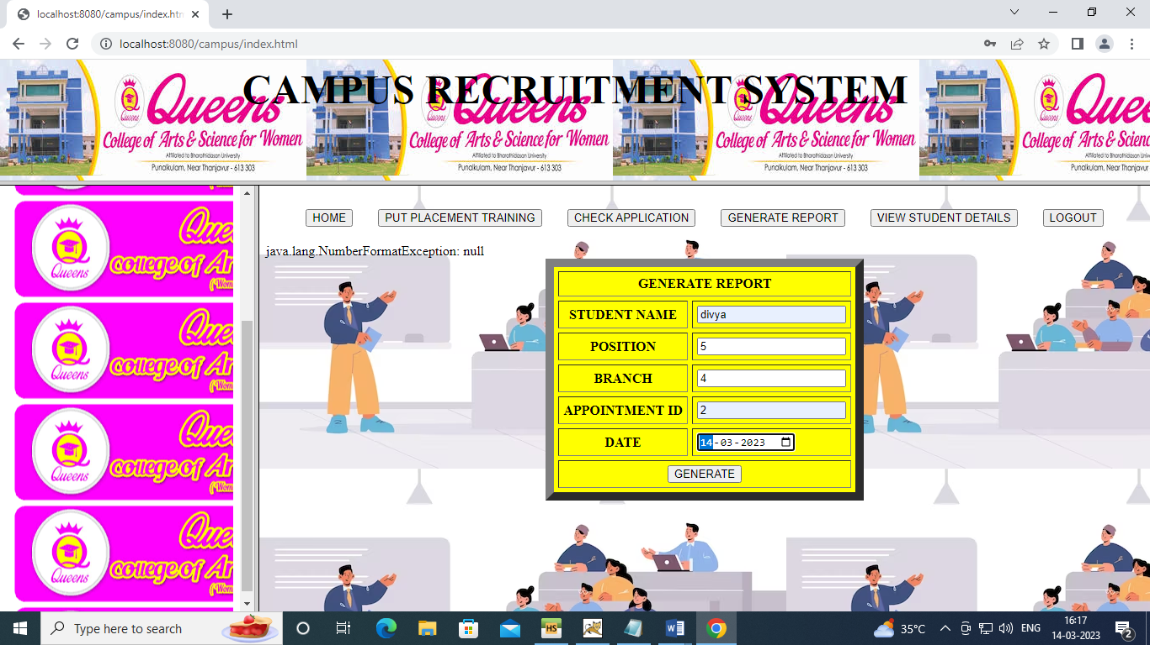

**VIEWSD**

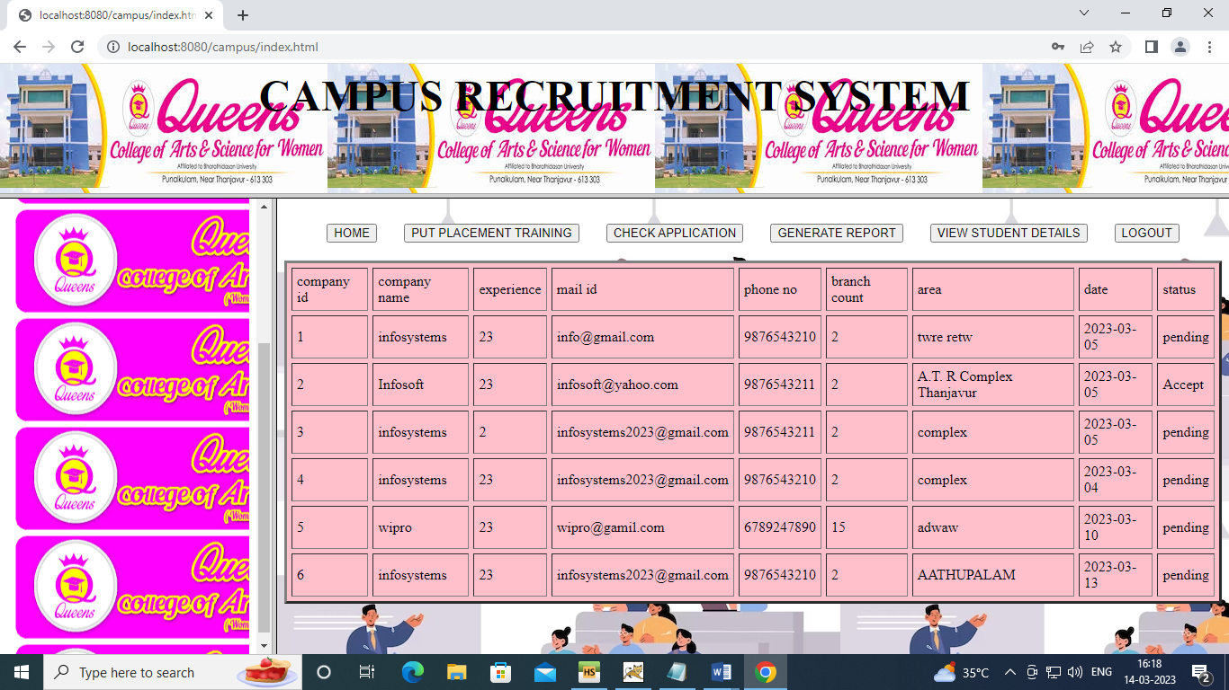

**REGISTER**

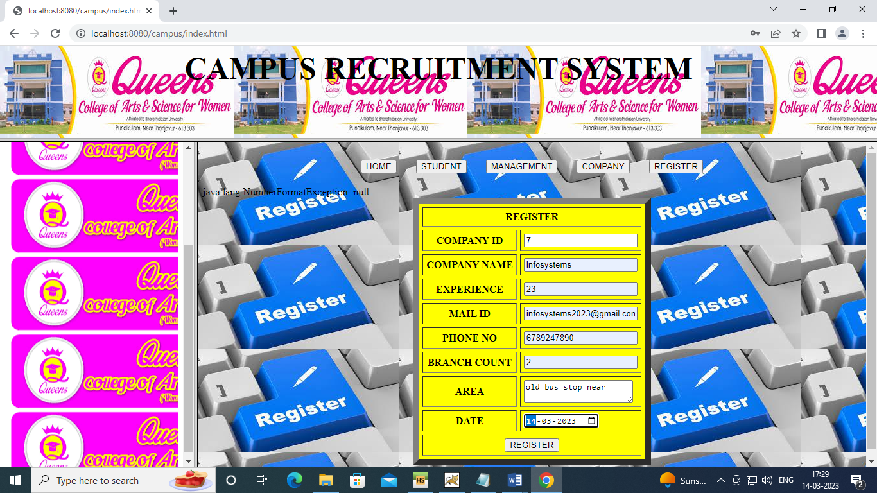

**8. CONCLUSION**

Campus Recruitment System aims at providing the compatibility to simplify the process of placement for students. This system consists of a student login, company login, and admin login. It is beneficial for college students, various companies visiting the campus for recruitment, and even the college placement officer. The software system allows the students to create their profiles and upload all their details including their marks onto the system. The admin can check each student’s details and can remove faulty accounts.

**9. BIBLIOGRAPHY**

* Brezinski and T. Killalea. Guidelines for evidence collection andArchiving. RFC 3227, IETF, 2002.
* Stephen D. Wolthusen, Overcast: Forensic Discovery in Cloud Environments, 5th International Conference on ITS Security Incident Management and IT Forensics, pages: 3-9, 2009.
* Cheng Yan, Cybercrime forensic system in cloud computing, ImageAnalysis and Signal Processing (IASP), pages: 612-615, 2011.
* Stephen Biggs, StilianosVidalis. Cloud Computing: The impact on Digital forensic investigations. International Conference for Internet Technology and Secured Transactions, pages: 1-6, 2009.
* Hong Guo; Bo Jing. Forensic investigations in Cloud environments. International Conference on Computer Science and Information Processing (CSIP), pages: 248-251, 2012.

WEBSITE

www.Java 2s.com

www.Rose india.com